Experiment 1.1: Write a HTML program, to explain the working of lists. Note: It should have an ordered list, unordered list, nested lists and ordered list in an unordered list and definition lists.

Program:

<!DOCTYPE html>

<head>

<title>HTML Lists Example</title>

</head>

<body>

<h1>Demonstration of HTML Lists</h1>

<h2>Ordered List</h2>

<ol>

<li>Item One</li>

<li>Item Two</li>

<li>Item Three</li>

</ol>

<h2>Unordered List</h2>

<ul>

<li>Apple</li>

<li>Banana</li>

<li>Cherry</li>

</ul>

<h2>Nested Lists</h2>

<ul>

<li>Fruits

<ul>

<li>Apple</li>

<li>Banana</li>

</ul>

</li>

<li>Vegetables

<ul>

<li>Carrot</li>

<li>Broccoli</li>

</ul>

</li>

</ul>

<h2>Ordered List Inside an Unordered List</h2>

<ul>

<li>Steps to Make Coffee

<ol>

<li>Boil water</li>

<li>Add coffee powder</li>

<li>Pour into a cup</li>

<li>Add milk and sugar</li>

</ol>

</li>

</ul>

<h2>Definition List</h2>

<dl>

<dt>HTML</dt>

<dd>HyperText Markup Language - The standard language for creating web pages.</dd>

<dt>CSS</dt>

<dd>Cascading Style Sheets - Used for styling web pages.</dd>

<dt>JavaScript</dt>

<dd>A scripting language for making web pages interactive.</dd>

</dl>

</body>

</html>

Output:

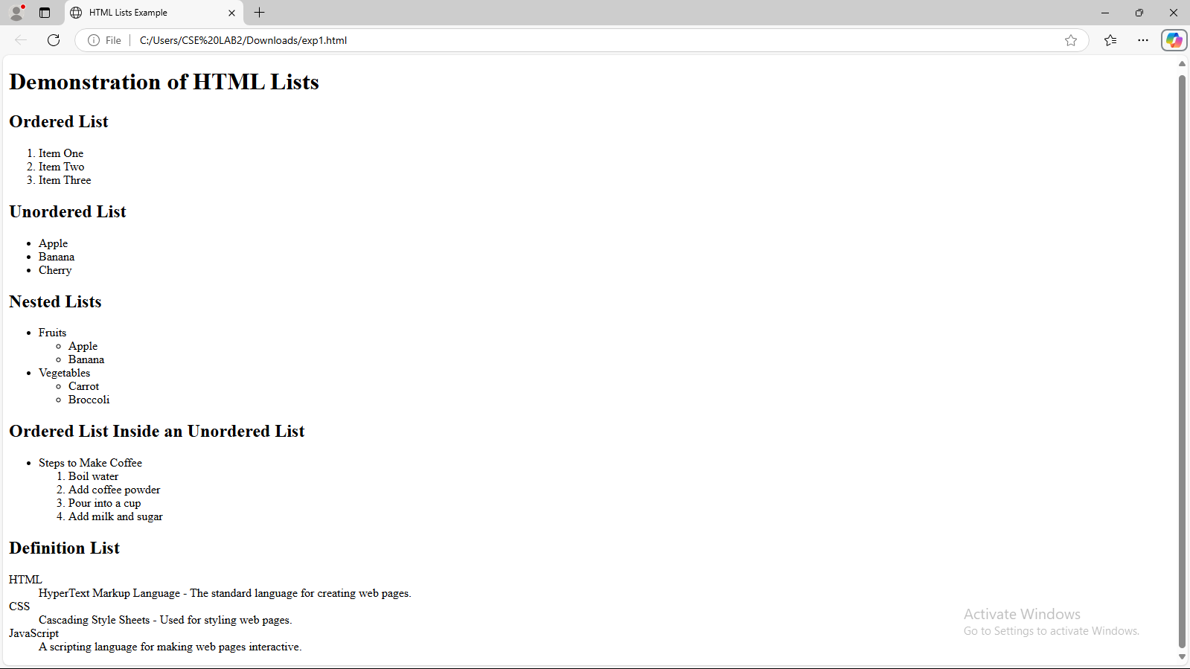

Experiment 1.2: Write a HTML program, to explain the working of hyperlinks using tag and href, target Attributes.

Program:

<!DOCTYPE html>

<head>

<title>HTML Hyperlinks Example</title>

</head>

<body>

<h1>Demonstration of HTML Hyperlinks</h1>

<h2>Basic Hyperlink</h2>

<p>Click the link below to visit Google:</p>

<a href="https://www.google.com">Visit Google</a>

<h2>Hyperlink with target Attribute</h2>

<p>Click the link below to open Google in a new tab:</p>

<a href="https://www.google.com" target="_blank">Open Google in New Tab</a>

<h2>Hyperlink to an Email</h2>

<p>Click the link below to send an email:</p>

<a href="mailto:someone@sasi.ac.in">Send Email</a>

</body>

</html>

Output:

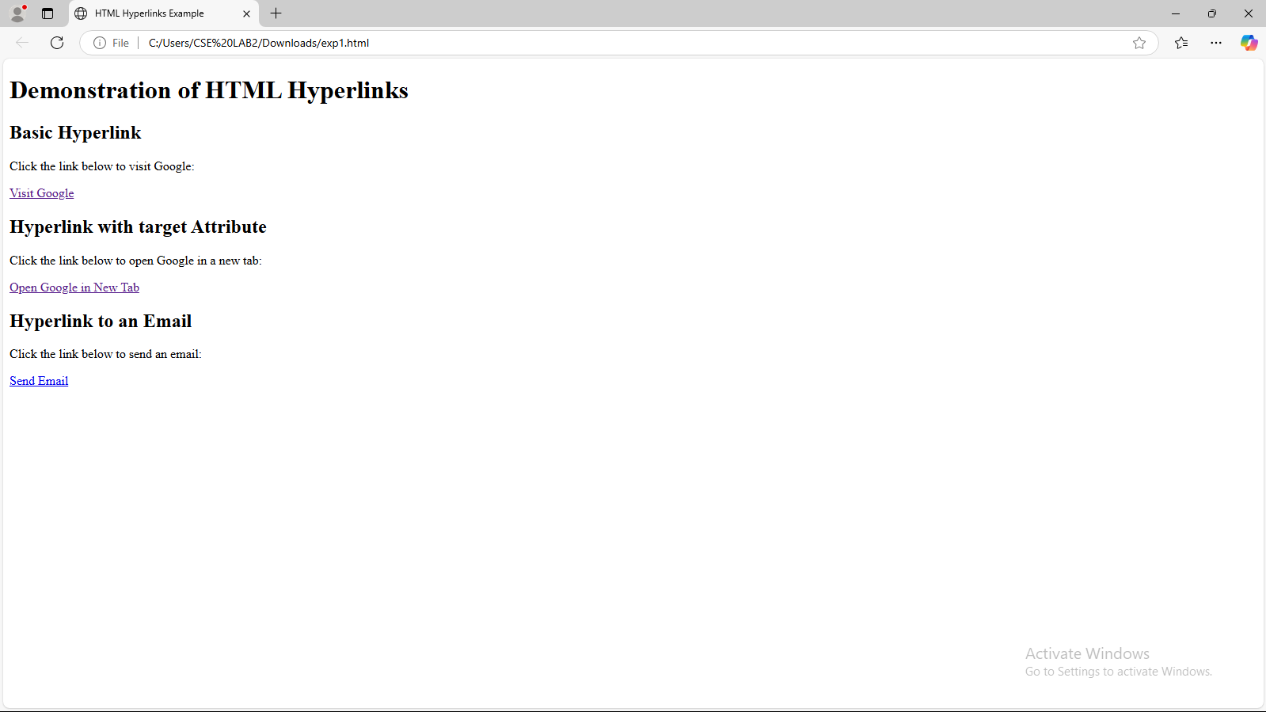

Experiment 1.3: Create a HTML document that has your image and your friend’s image with a specific height and width. Also when clicked on the images it should navigate to their respective profiles.

Program:

<!DOCTYPE html>

<head>

<title>HTML Image Hyperlinks</title>

</head>

<body>

<h1>Image Hyperlinks Example</h1>

<h2>Image1</h2>

<a href="https://www.thehindu.com/news/national/prime-minister-narendra-modi-birthday-september-17-2022/article65901813.ece" target="_blank">

<img src="1.jpg" alt="My Image" width="200" height="200">

</a>

<h2>Image2</h2>

<a href="https://en.wikipedia.org/wiki/Pawan_Kalyan_filmography" target="_blank">

<img src="2.jpg" alt="Friend's Image" width="200" height="200">

</a>

</body>

</html>

Output:

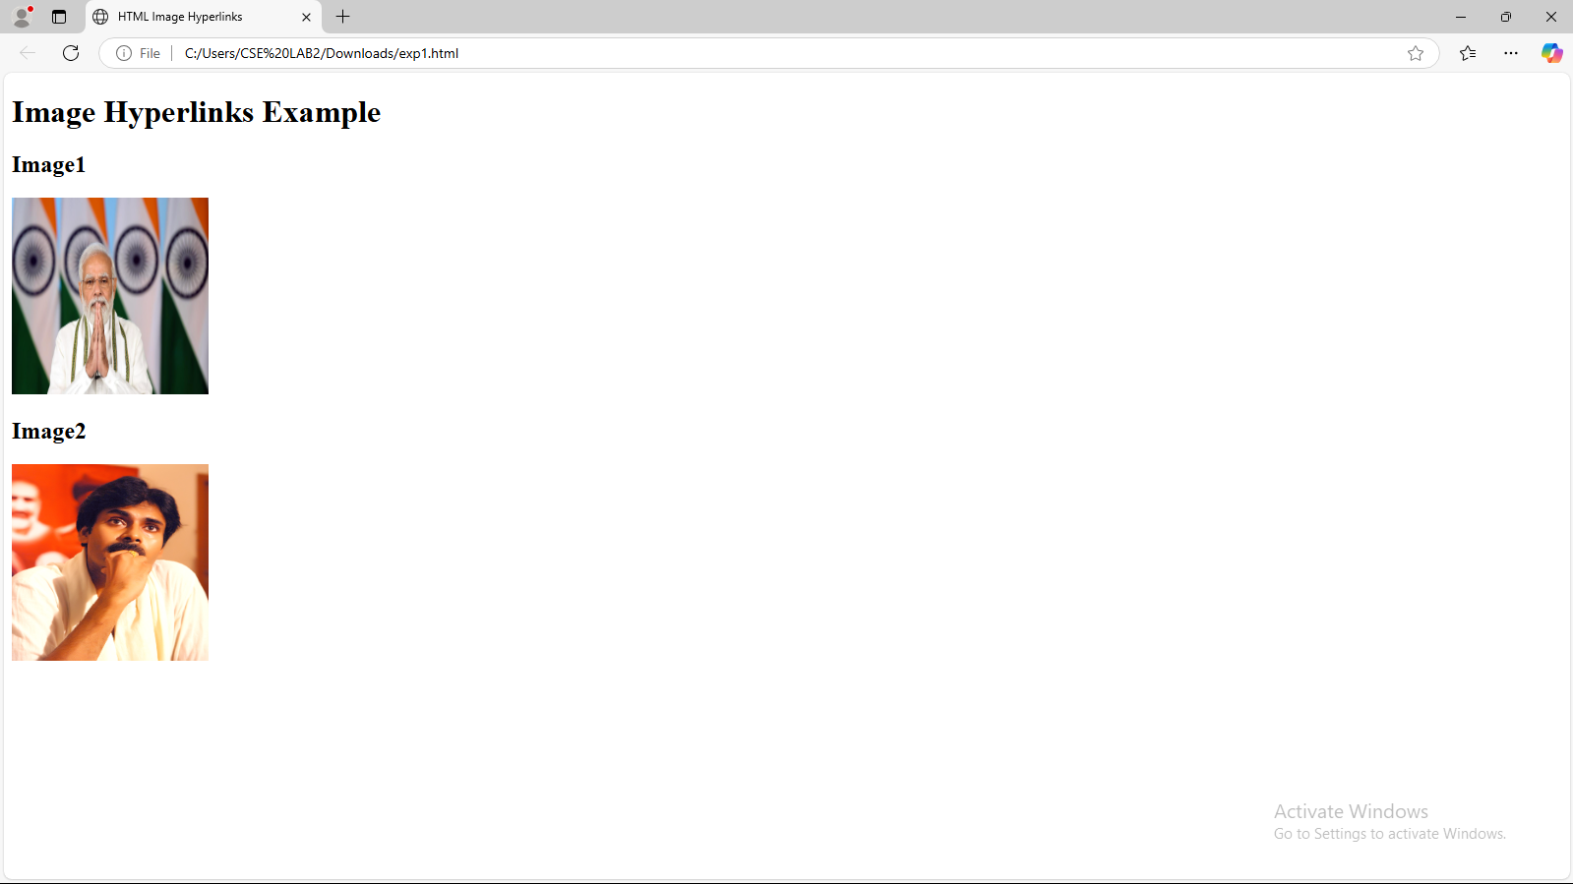

Experiment 1.4: Write a HTML program, in such a way that, rather than placing large images on a page, the preferred technique is to use thumbnails by setting the height and width parameters to something like to 100*100 pixels. Each thumbnail image is also a link to a full sized version of the image. Create an image gallery using this technique

Program:

<!DOCTYPE html>

<head>

<title>Image Gallery with Thumbnails</title>

</head>

<body>

<h1>Image Gallery</h1>

<h2>Thumbnail Gallery</h2>

<a href="1.jpg" target="_blank">

<img src="thumb1.jpg" alt="Image 1" width="100" height="100">

</a>

<a href="2.jpg" target="_blank">

<img src="thumb2.jpg" alt="Image 2" width="100" height="100">

</a>

<a href="3.jpg" target="_blank">

<img src="thumb3.jpg" alt="Image 3" width="100" height="100">

</a>

</body>

</html>

Output: 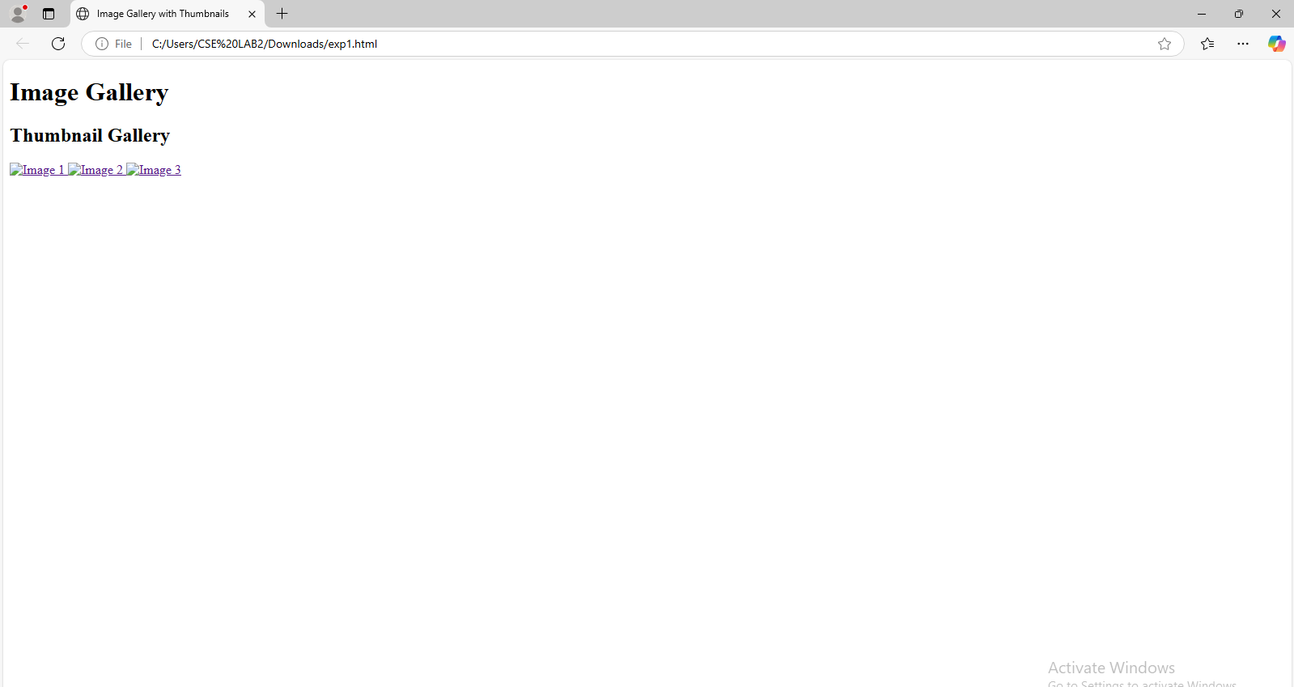 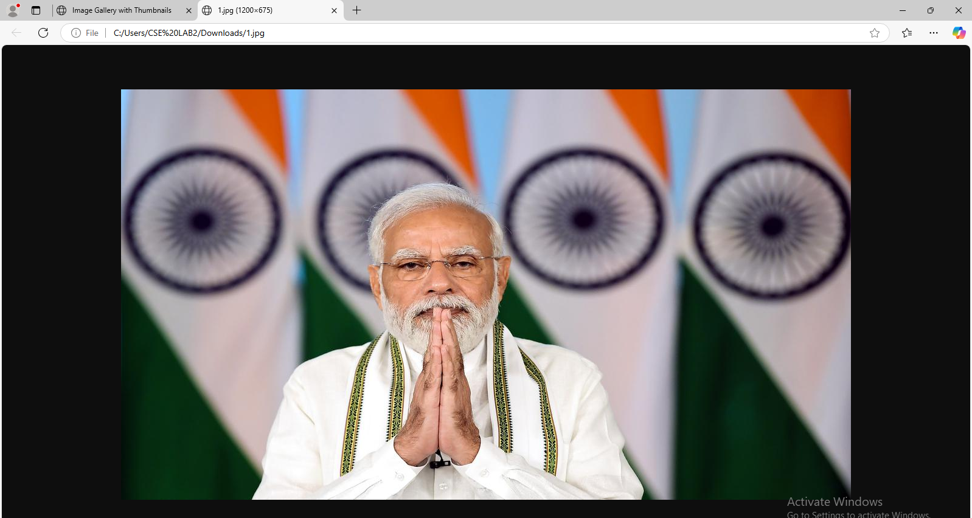 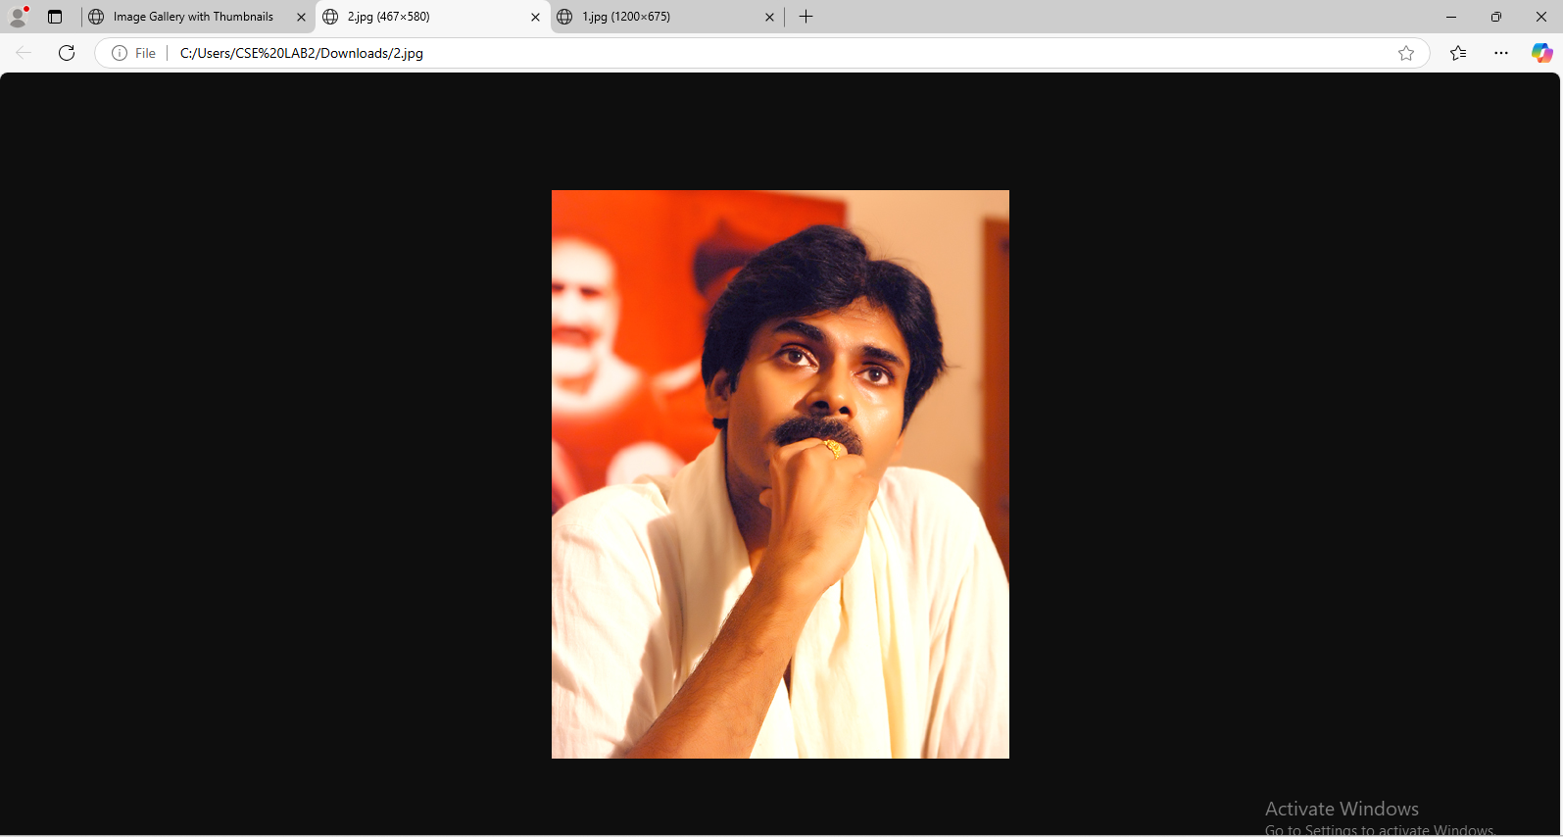 

Experiment 2.1: Write a HTML program, to explain the working of tables. (use tags:

|  |  |
| --- | --- |
| , ,  **,** | and attributes: border, rowspan, colspan) |

Program:

<!DOCTYPE html>

<html lang="en">

<head>

<title>HTML Table Example </title>

</head>

<body>

<h2>HTML Table Example: Use of <code>&lt;table&gt;</code>, <code>&lt;tr&gt;</code>, <code>&lt;th&gt;</code>, <code>&lt;td&gt;</code>, and Attributes</h2>

<!-- Table with border -->

<table border="2" cellpadding="10" cellspacing="0">

<caption>Product Inventory</caption>

<tr>

<!-- Header Row -->

<th>Product ID</th>

<th>Product Name</th>

<th>Price</th>

<th>Category</th>

</tr>

<tr>

<!-- First Data Row -->

<td>101</td>

<td>Smartphone</td>

<td>$699</td>

<td>Electronics</td>

</tr>

<tr>

<!-- Second Data Row -->

<td>102</td>

<td>Laptop</td>

<td>$1299</td>

<td>Electronics</td>

</tr>

<tr>

<!-- Third Data Row with colspan -->

<td>103</td>

<td>Headphones</td>

<td>$150</td>

<td colspan="2">Accessories</td> <!-- This cell spans 2 columns -->

</tr>

<tr>

<!-- Fourth Data Row with rowspan -->

<td rowspan="2">104</td> <!-- This cell spans 2 rows -->

<td>Smartwatch</td>

<td>$199</td>

<td>Accessories</td>

</tr>

<tr>

<td>Fitness Tracker</td>

<td>$99</td>

<td>Accessories</td>

</tr>

</table>

</body>

</html>

Output:

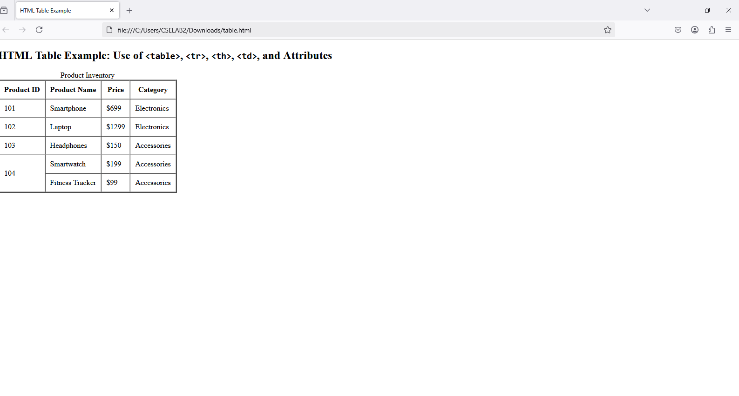

Experiment 2.2: Write a HTML program, to explain the working of tables by preparing a timetable. (Note: Use tag to set the caption to the table & also use cell spacing, cell padding, border, rowspan, colspan etc.).

Program:

<!DOCTYPE html>

<html lang="en">

<head>

<title>Time Table</title>

<style>

table {

width: 100%;

border-collapse: collapse;

}

th, td {

padding: 15px;

text-align: center;

border: 1px solid black;

}

tr:nth-child(even) {

background-color: #D6EEEE;

}

</style>

</head>

<body>

<table>

<caption><h1>CSE-Time Table</h1></caption>

<tr>

<th>Day</th>

<th>9:00-10:00</th>

<th>10:00-11:00</th>

<th>11:00-11:10</th>

<th>11:10-12:10</th>

<th>12:10-1:10</th>

<th>1:10-2:10</th>

<th>2:10:3:10</th>

<th>3:10-4:10</th>

</tr>

<tr>

<td>Monday</td>

<td>SE</td>

<td>DBMS</td>

<td>BREAK</td>

<td>MEFA</td>

<td>OS</td>

<td>LUNCH BREAK</td>

<td>P&S</td>

<td>SE</td>

</tr>

<tr>

<td>Tuesday</td>

<td>FSD</td>

<td>SE</td>

<td>BREAK</td>

<td colspan="2">TT</td>

<td>LUNCH BREAK</td>

<td colspan="2">TLP</td>

</tr>

<tr>

<td>Wednesday</td>

<td colspan="2">VS</td>

<td>BREAK</td>

<td>OS</td>

<td>MEFA</td>

<td>LUNCH BREAK</td>

<td>SE</td>

<td>DBMS</td>

</tr>

<tr>

<td>Thursday</td>

<td colspan="2">OS/DBMS LAB</td>

<td>BREAK</td>

<td colspan="2">DTI</td>

<td>LUNCH BREAK</td>

<td>P&S</td>

<td>OS</td>

</tr>

<tr>

<td>Friday</td>

<td>OS</td>

<td>DBMS</td>

<td>BREAK</td>

<td>P&S</td>

<td>MEFA</td>

<td>LUNCH BREAK</td>

<td colspan="2">FSD Lab</td>

</tr>

<tr>

<td>Saturday</td>

<td colspan="2">DBMS/OS LAB</td>

<td>BREAK</td>

<td>P&S</td>

<td>DTI</td>

<td>LUNCH BREAK</td>

<td>DBMS</td>

<td>MEFA</td>

</tr>

</table>

</body>

</html>

Output:

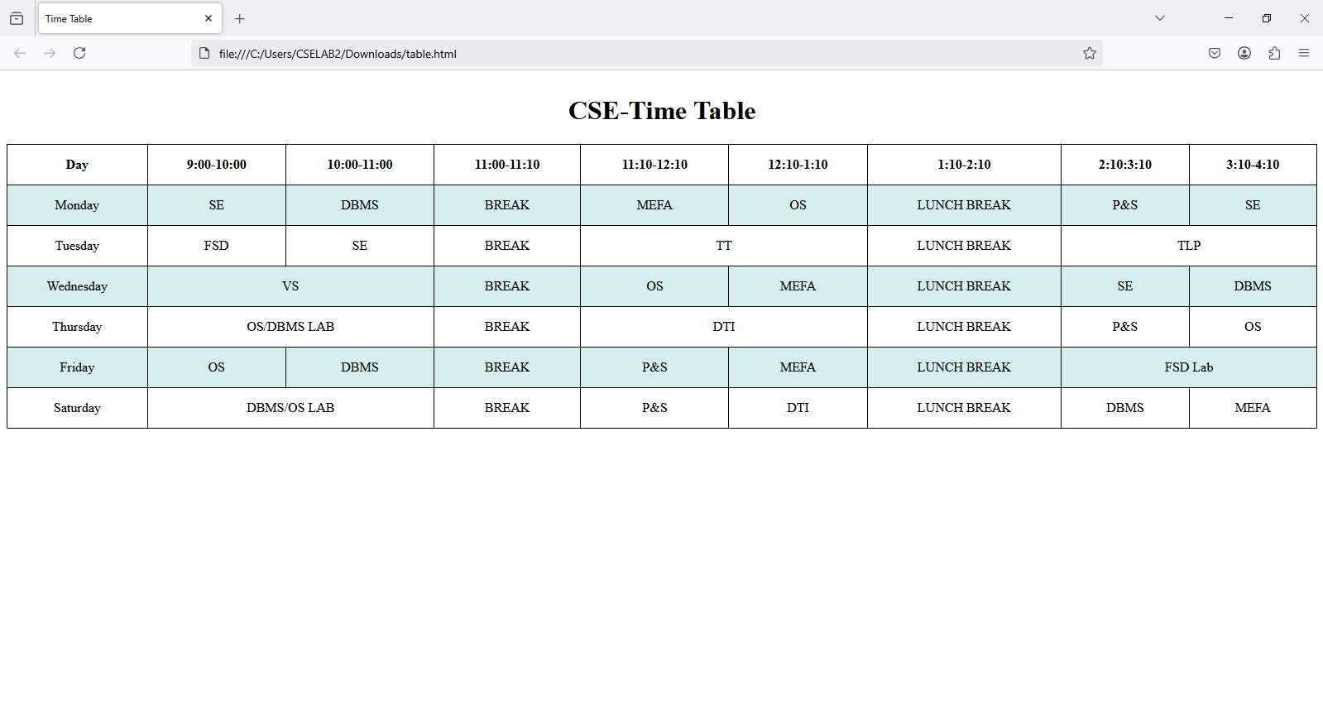

Experiment 2.3: Write a HTML program, to explain the working of forms by designing Registration form. (Note: Include text field, password field, number field, date of birth field, checkboxes, radio buttons, list boxes using and two buttons ie: submit and reset. Use tables to provide a better view).

Program:

<html>

<body bgcolor="lavender">

<form align="center">

<table align="center">

<h1 align="center"><i>Login page</i></h1>

<caption><h3>Sign Up</h3></caption>

<tr><td><label>Name:</label></td><td><input type="text"></td></tr>

<tr><td><label>Mobile:</label></td><td><input type="number" autocomplete="on"></td></tr>

<tr><td><label>Date of birth:</label></td><td><input type="date"></td></tr>

<tr><td><label>Gender: </label><td><input type="radio" name="gender" value="Male"> Male <input type="radio" name="gender" value="Female"> Female</td></tr>

<tr><td><label>Email:</label></td><td><input type="email"></td></tr>

<tr><td><label>Username:</label></td><td><input type="text" pattern="[A-Za-z]+" maxlength="20" minlength="9"></td></tr>

<tr><td><label>Password:</label></td><td><input type="password" placeholder="********"></td></tr>

<tr><td><label>Confirm Password:</label></td><td><input type="password" placeholder="********"></td></tr>

<tr><td><label>Address :<br></label></td><td><textarea rows="3" cols="30" spellcheck="true"></textarea></td></tr>

</table>

<div style="text-align: center; margin-top: 20px;">

<button type="submit" class="submit-btn">Sign Up</button>

</div>

</form>

</body>

</html>

Output:

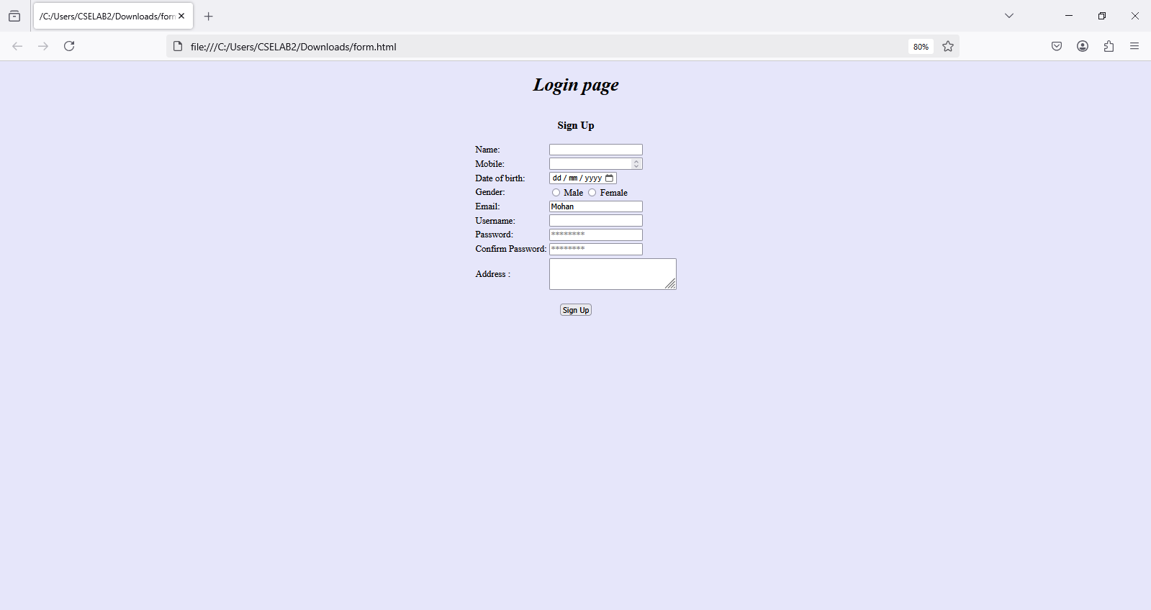

Experiment 2.4: Write a HTML program, to explain the working of frames, such that page is to be divided into 3 parts on either direction. (Note: first frame ◊ image, second frame ◊ paragraph, third frame ◊ hyperlink. And also make sure of using “no frame” attribute such that frames to be fixed).

Program:

<!DOCTYPE html>

<html>

<head>

<title>Frames</title>

</head>

<frameset cols"30%,30%,*>

<frame src="img.html></frames>

<frame src="para.html></frames>

<frame src="hyper.html></frames>

</frameset>

</head>

</html>

img.html

<html>

<head>

<title>image</title>

</head>

<img src="img.jpg" width="500px">

</body>

</html>

Para.html

<html>

<head>

<title>paragraph</title>

</head>

<p>This is test in frame</p>

</body>

</html>

hyper.html

<!DOCTYPE html>

<html>

<head>

<title>Hyperlinks</title>

</head>

<body>

<a href="https://sasi.ac.in/" target="_blank">Visit Sasi Institute</a>

</body>

</html>

Output:

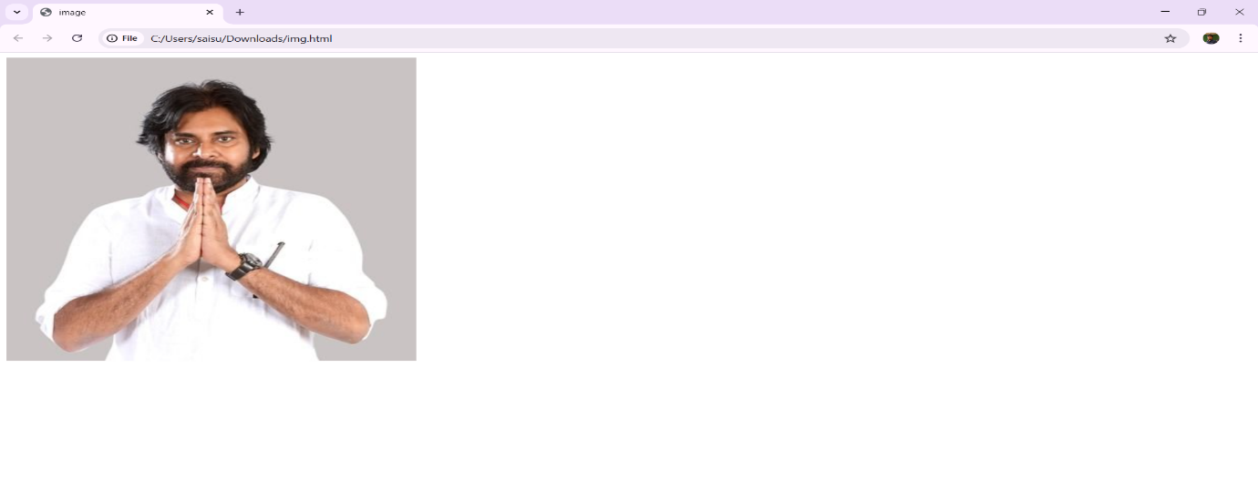

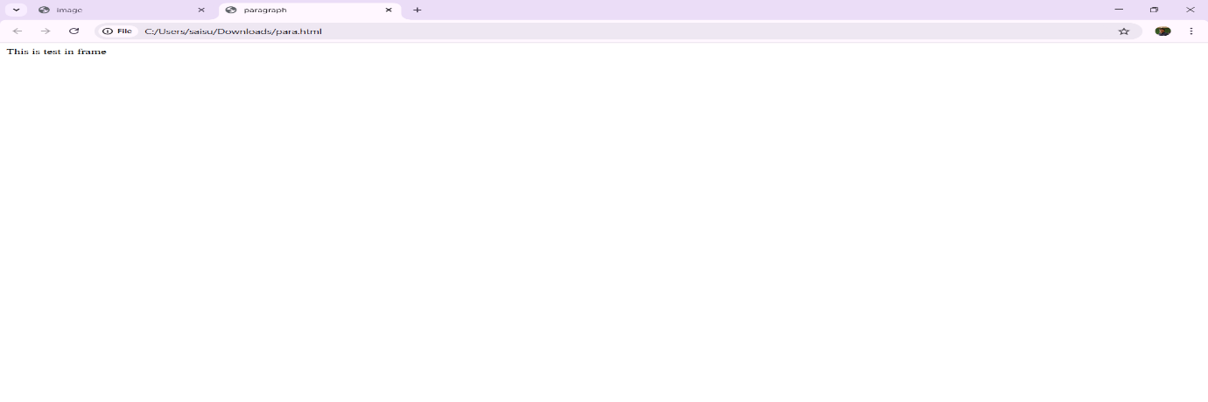

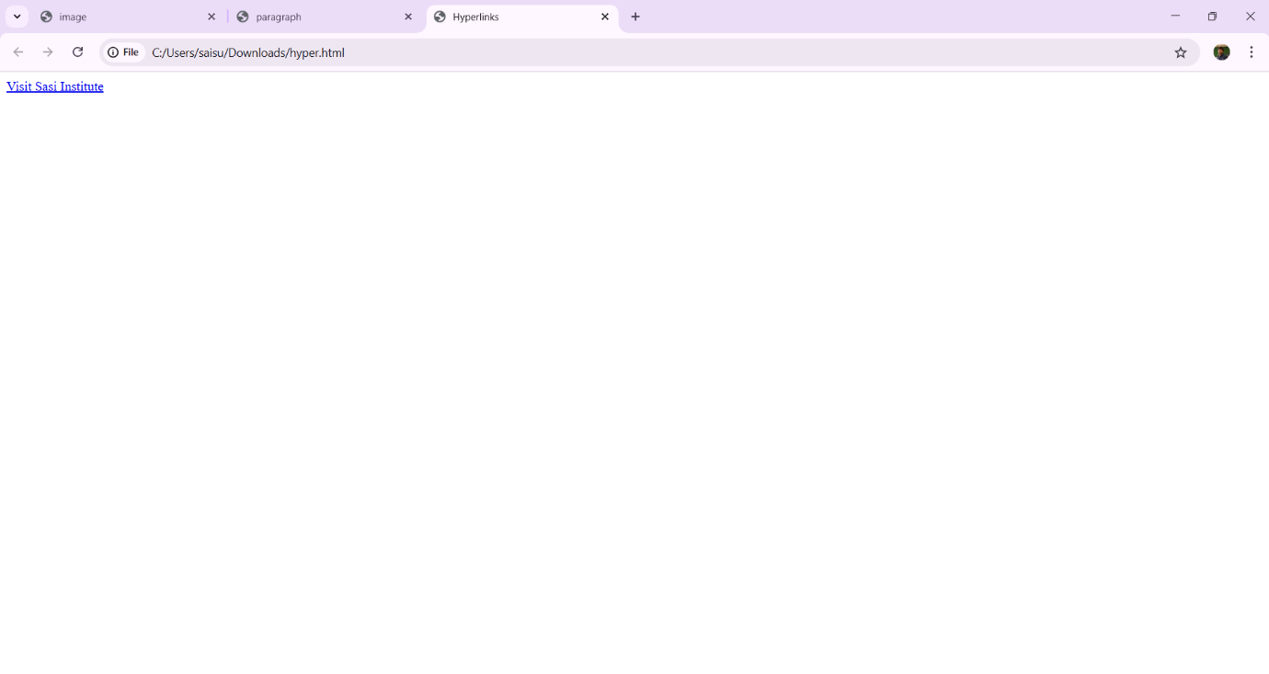



Experiment 3.1: Write a HTML program, that makes use of <article>, <aside>, <figure>, <figcaption>, <footer>, <header>, <main>, <nav>, <section>, <div>, <span> tags.

Program:

<!DOCTYPE html>

<html lang="en">

<head>

<title>Simple HTML5 Example</title>

</head>

<body>

<!-- Header Section -->

<header>

<h1>Simple Example</h1>

</header>

<!-- Navigation Section -->

<nav>

<a href="#home">Home</a> |

<a href="#about">About</a>

</nav>

<!-- Main Content Section -->

<main>

<article>

<header>

<h2>Article Title</h2>

</header>

<section>

<p>This is the main content of the article.</p>

</section>

<footer>

<p>Written by Author</p>

</footer>

</article>

<!-- Aside Section -->

<aside>

<h3>Related Links</h3>

<ul>

<li><a href="#">Link 1</a></li>

<li><a href="#">Link 2</a></li>

</ul>

</aside>

</main>

<!-- Footer Section -->

<footer>

<p>&copy; 2025 Simple HTML Example</p>

</footer>

</body>

</html>

Output:

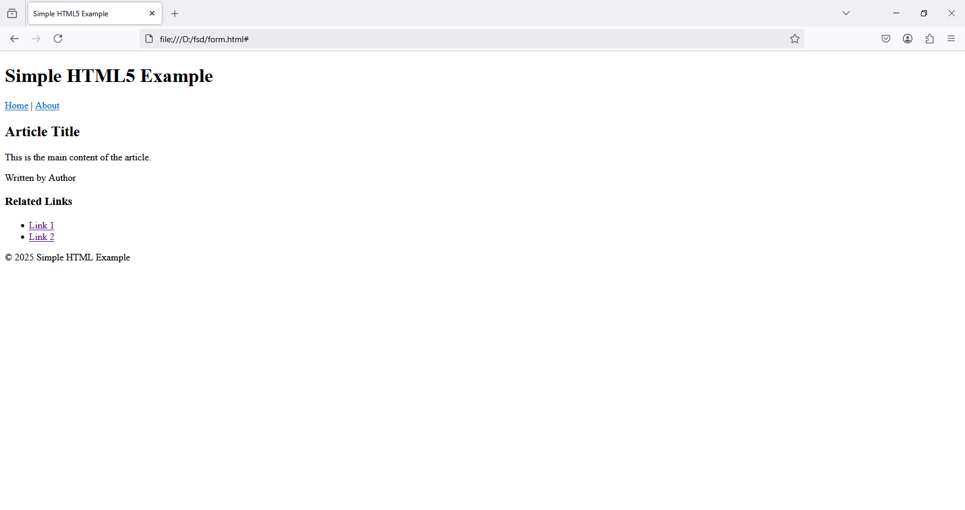

Experiment 3.2: Write a HTML program, to embed audio and video into HTML web page.

Program:

<!DOCTYPE html>

<html lang="en">

<head>

<title>Embed Audio and Video</title>

</head>

<body>

<h1>Audio and Video Embedding Example</h1>

<!-- Audio Embed -->

<section>

<h2>Audio Example</h2>

<audio controls>

<source src="audio.mp3" type="audio/mp3">

Your browser does not support the audio element.

</audio>

</section>

<br><br>

<!-- Video Embed -->

<section>

<h2>Video Example</h2>

<video width="640" height="360" controls>

<source src="video1.mp4" type="video/mp4">

Your browser does not support the video tag.

</video>

</section>

</body>

</html>

Output:

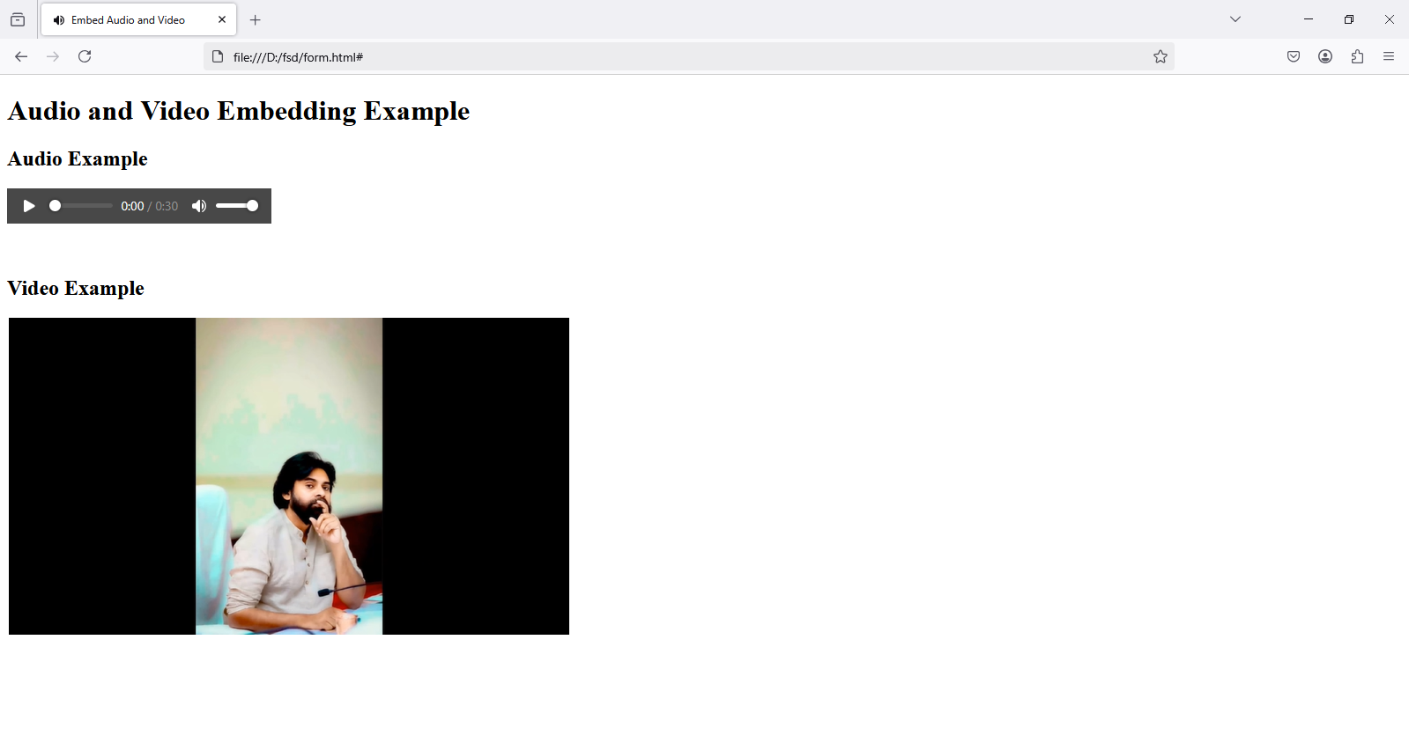

Experiment 3.3: Write a program to apply different types (or levels of styles or style specification formats) - inline, internal, external styles to HTML elements. (identify selector, property and value).

Program:

<!DOCTYPE html>

<html>

<head>

<title>Style Specification Formats</title>

<style>

/* Internal CSS */

body {

font-family: Arial, sans-serif;

background-color: #f4f4f4;

text-align: center;

}

h1 {

color: blue;

}

.styled-text {

color: green;

font-size: 20px;

}

</style>

<link rel="stylesheet" type="text/css" href="styles.css"> <!-- External CSS -->

</head>

<body>

<h1>CSS Styling in HTML</h1>

<h2 style="color: red;">Inline CSS Example</h2>

<p style="font-weight: bold; color: purple;">This is an example of inline CSS.</p>

<h2>Internal CSS Example</h2>

<p class="styled-text">This paragraph is styled using internal CSS.</p>

<h2>External CSS Example</h2>

<p class="external-style">This paragraph is styled using external CSS (referenced in styles.css).</p>

</body>

</html>

Output:

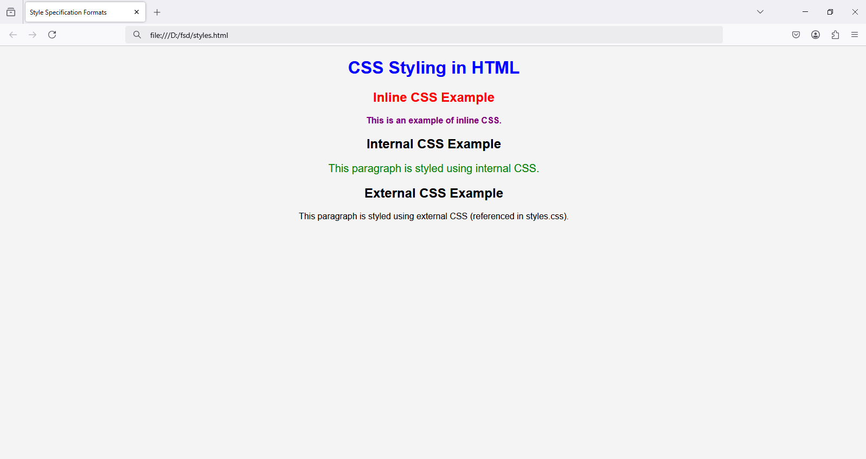

Experiment 4.: Selector forms a. Write a program to apply different types of selector forms i. Simple selector (element, id, class, group, universal) ii. Combinator selector (descendant, child, adjacent sibling, general sibling) iii.Pseudo-class selector iv. Pseudo-element selector v. Attribute selector

4.1.Simple Selector:

1.Name:

Program:

<!DOCTYPE html>

<html>

<head>

<style>

a {

color: blue;

text-decoration: none;

}

</style>

</head>

<body>

<a href="https://sasi.ac.in/">This link is styled with the type selector.</a>

</body>

</html>

Output:

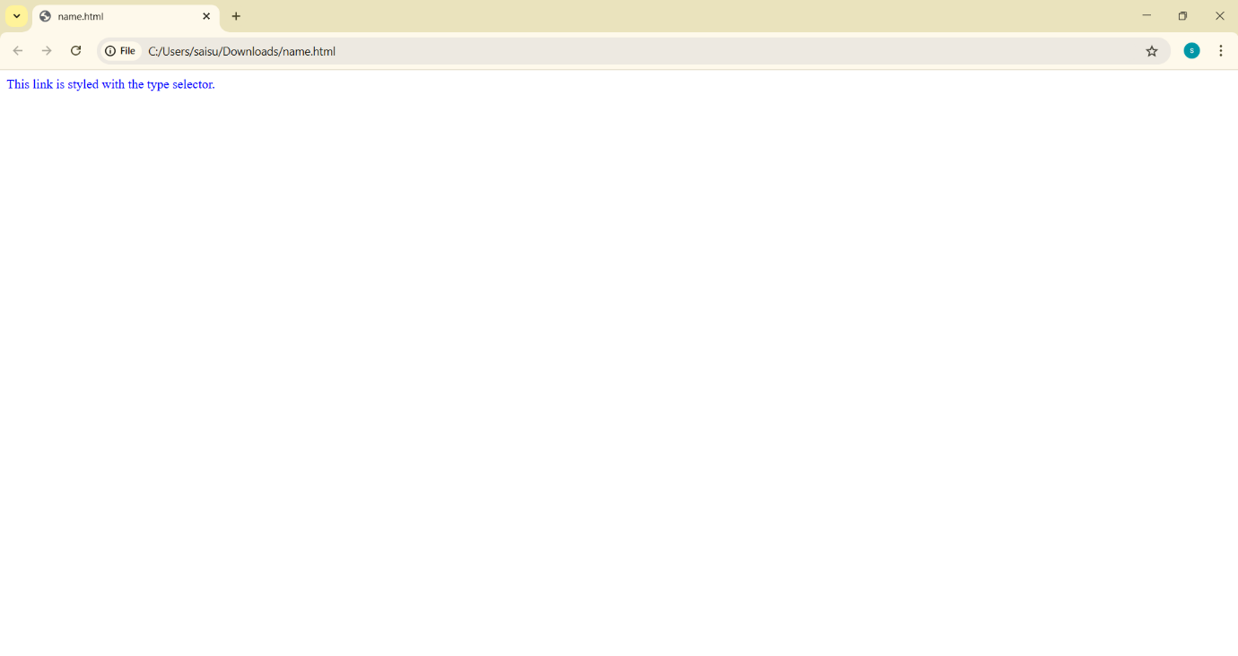



2.id

Program:

<!DOCTYPE html>

<html>

<head>

<style>

#uniqueLink {

color: green;

font-weight: bold;

}

</style>

</head>

<body>

<a id="uniqueLink" href="https://sasi.ac.in/">This link has unique styling via an ID selector.</a>

</body>

</html>

Output:

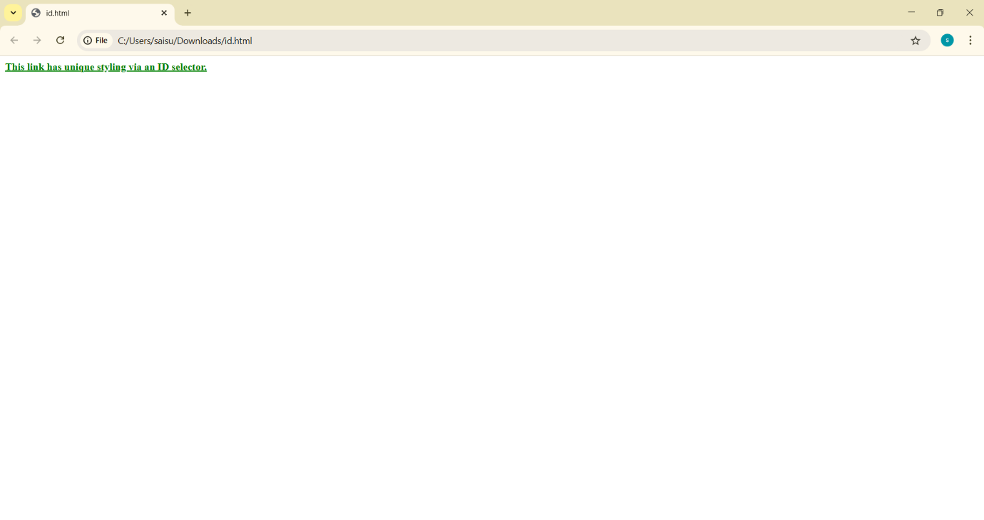



3.Class

Program: <!DOCTYPE html>

<html>

<head>

<style>

.button-link {

background-color: yellow;

padding: 5px 10px;

text-decoration: none;

border-radius: 4px;

}

</style>

</head>

<body>

<a class="button-link" href="https://sasi.ac.in/">Button Link 1</a>

<a class="button-link" href="https://sasi.codetantra.com/login.jsp">Button Link 2</a>

</body>

</html>

Output:

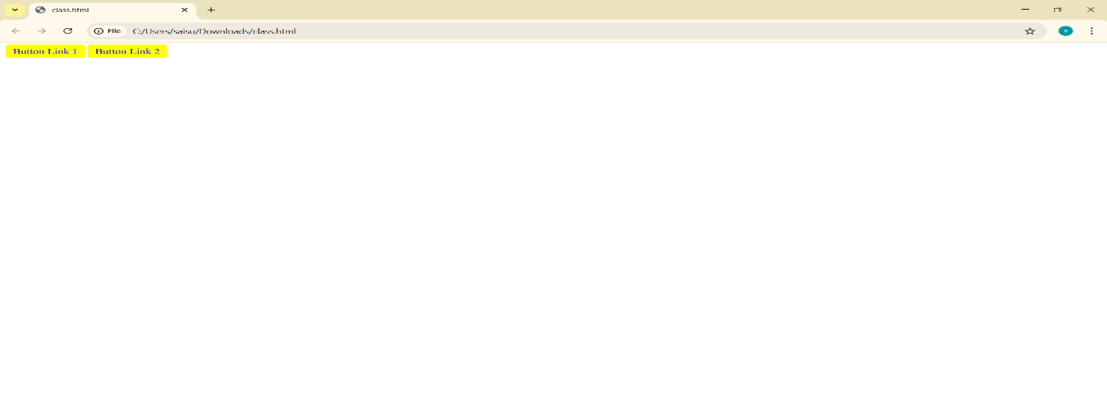



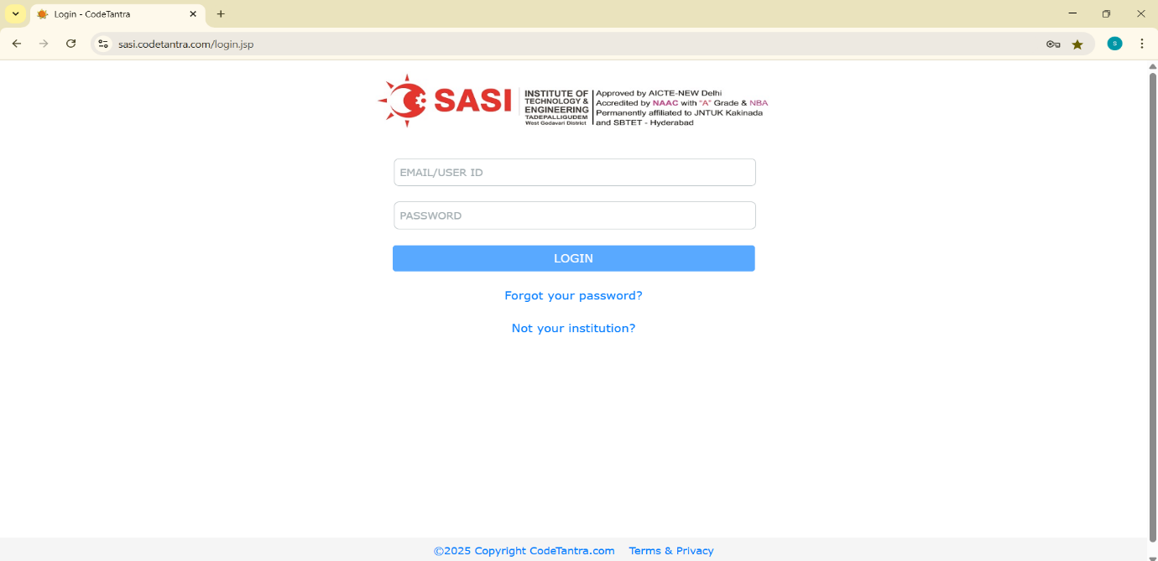

4.Universal:

Program:

<!DOCTYPE html>

<html>

<head>

<style>

* {

font-family: Arial, sans-serif;

margin: 0;

padding: 0;

}

</style>

</head>

<body>

<a href="https://sasi.ac.in/">This link inherits universal styling.</a>

</body>

</html>

Output:

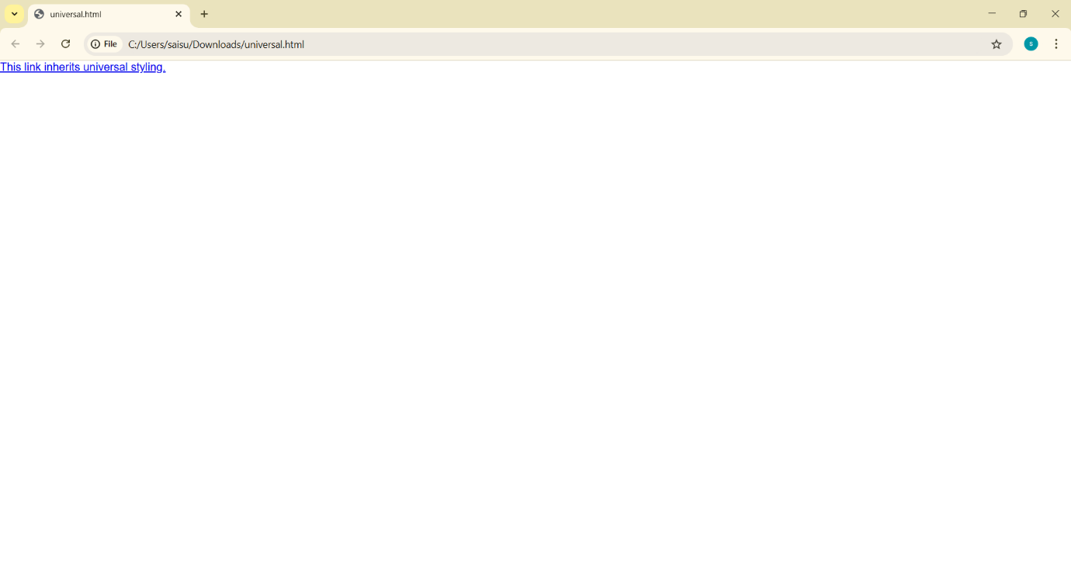



5.Grouping

Program:

<!DOCTYPE html>

<html>

<head>

<style>

a, p, h1 {

color: purple;

}

</style>

</head>

<body>

<h1>Heading styled via grouping selector</h1>

<p>Paragraph styled via grouping selector.</p>

<a href="https://sasi.ac.in/">This link is styled via grouping selector.</a>

</body>

</html>

Output:

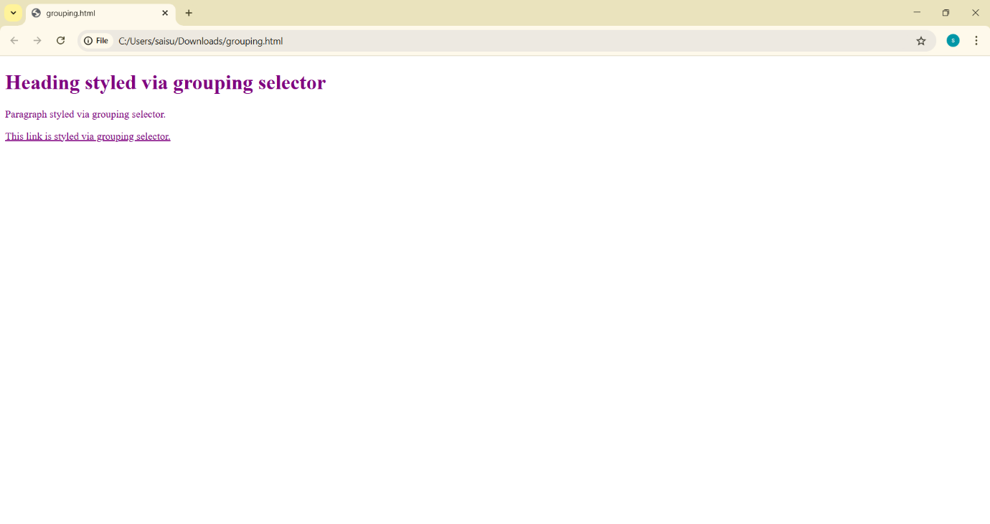



4.2Combinational Selector

1.Descendent:

Program:

<!DOCTYPE html>

<html>

<head>

<style>

div p {

color: blue;

}

</style>

</head>

<body>

<div>

<p>This paragraph inside a div is blue.</p>

</div>

<p>This paragraph outside the div is not styled.</p>

</body>

</html>

Output:

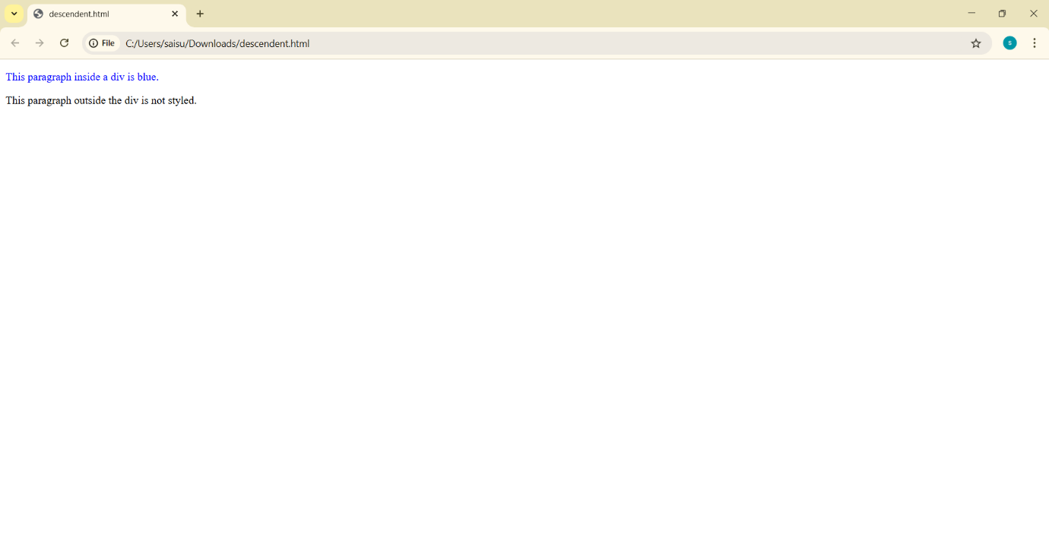

2.Child:

Program:

<!DOCTYPE html>

<html>

<head>

<style>

div > p {

color: green;

}

</style>

</head>

<body>

<div>

<p>This direct child paragraph inside the div is green.</p>

<div>

<p>This nested paragraph is not styled.</p>

</div>

</div>

</body>

</html>

Output:

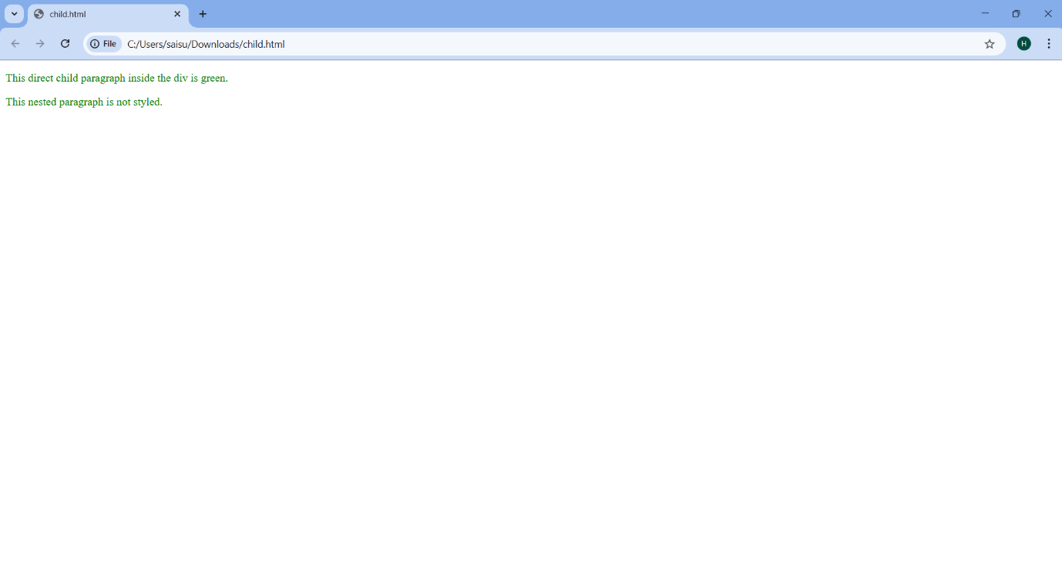

3.Adjacent sibiling

Program:

<!DOCTYPE html>

<html>

<head>

<style>

h1 + p {

color: red;

}

</style>

</head>

<body>

<h1>This is a heading.</h1>

<p>This paragraph comes immediately after the heading and is red.</p>

<p>This paragraph is not affected.</p>

</body>

</html>

Output:

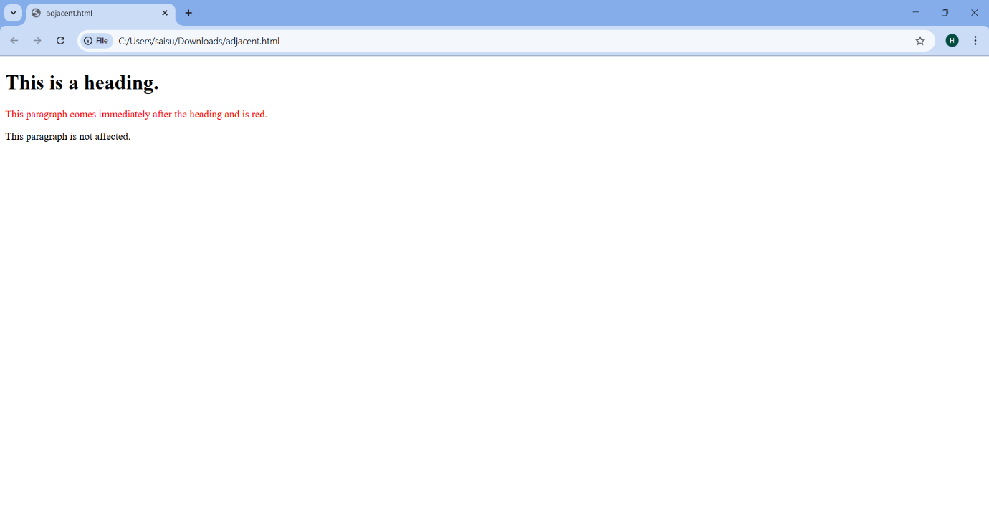

4.General Sibiling

Program:

<!DOCTYPE html>

<html>

<head>

<style>

h1 ~ p {

color: purple;

}

</style>

</head>

<body>

<h1>This is a heading.</h1>

<p>This paragraph is a sibling of the heading and is purple.</p>

<p>This one is also purple.</p>

</body>

</html>

Output:

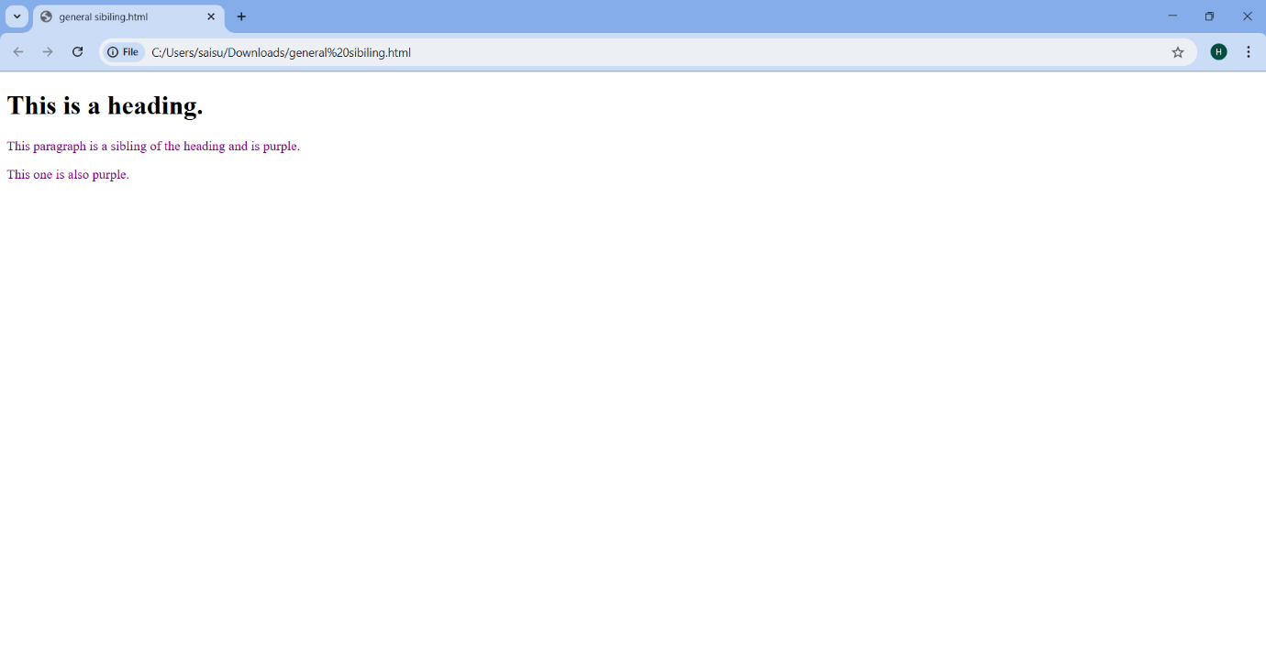

4.3 Pseudo-class selector

Program:

<!DOCTYPE html>

<html>

<head>

<title>Pseudo-Classes Example</title>

<style>

/* Unvisited links */

a:link {

color: blue;

text-decoration: none;

}

/* Visited links */

a:visited {

color: purple;

}

/* Links on hover */

a:hover {

color: green;

text-decoration: underline;

}

/* Links during active state (while clicking) */

a:active {

color: red;

}

</style>

</head>

<body>

<h1>Pseudo-Classes for Links</h1>

<p>

<a href="https://sasi.ac.in/">This is a link demonstrating all pseudo-classes.</a>

</p>

</body>

</html>

Output:

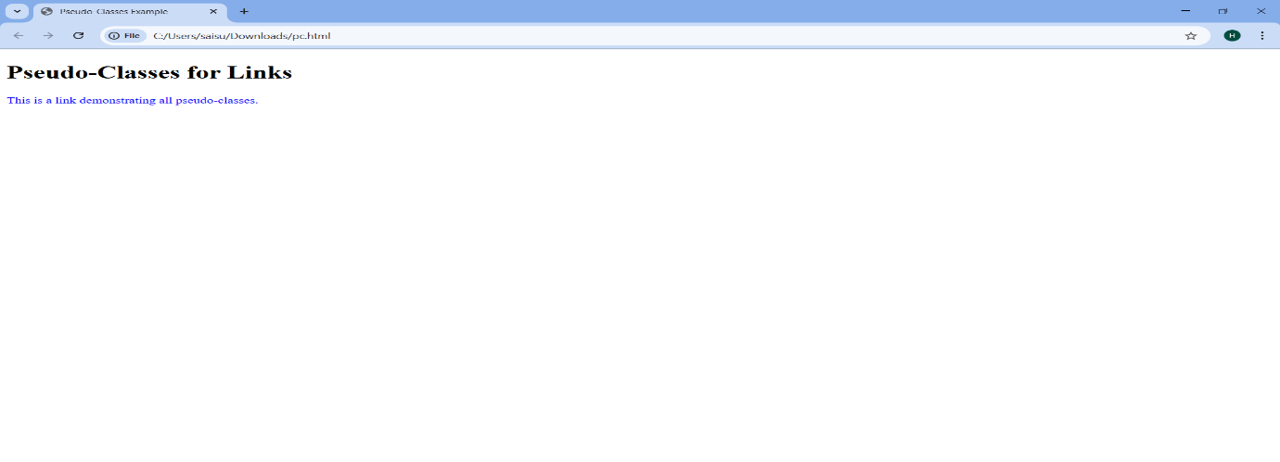

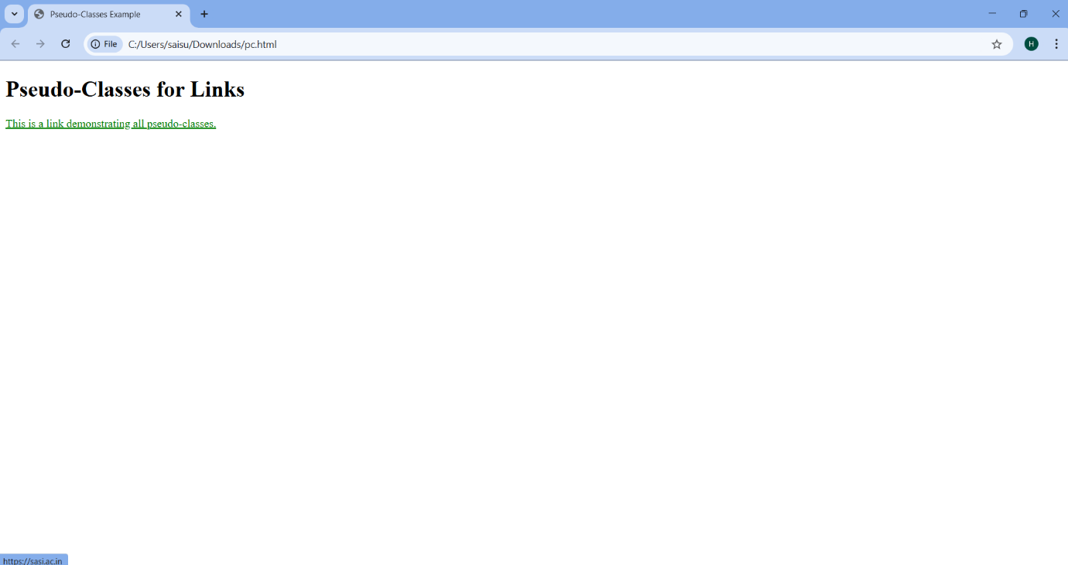



4.4. Pseudo-element selector:

Program:

<!DOCTYPE html>

<html>

<head>

<title>Combined CSS Example</title>

<style>

/* First line of a paragraph */

p::first-line {

color: blue;

font-weight: bold;

}

/* First character of a paragraph */

p::first-letter {

color: red;

font-size: 2em;

}

/* Adding content before and after elements */

h1::before {

content: "$ ";

color: gold;

}

h1::after {

content: " $";

color: gold;

}

/* Customizing list marker styles */

ul {

list-style-type: square; /* Changing markers to squares */

}

ol {

list-style-type: upper-roman; /* Using Roman numerals for ordered lists */

}

</style>

</head>

<body>

<h1>Combined CSS Styling</h1>

<p>This is a paragraph demonstrating multiple pseudo-elements and styles.<br> The first line is blue and bold, and the first character is larger and red.</p>

<ul>

<li>First item in an unordered list</li>

<li>Second item in an unordered list</li>

</ul>

<ol>

<li>First item in an ordered list</li>

<li>Second item in an ordered list</li>

</ol>

</body>

</html>

Output:

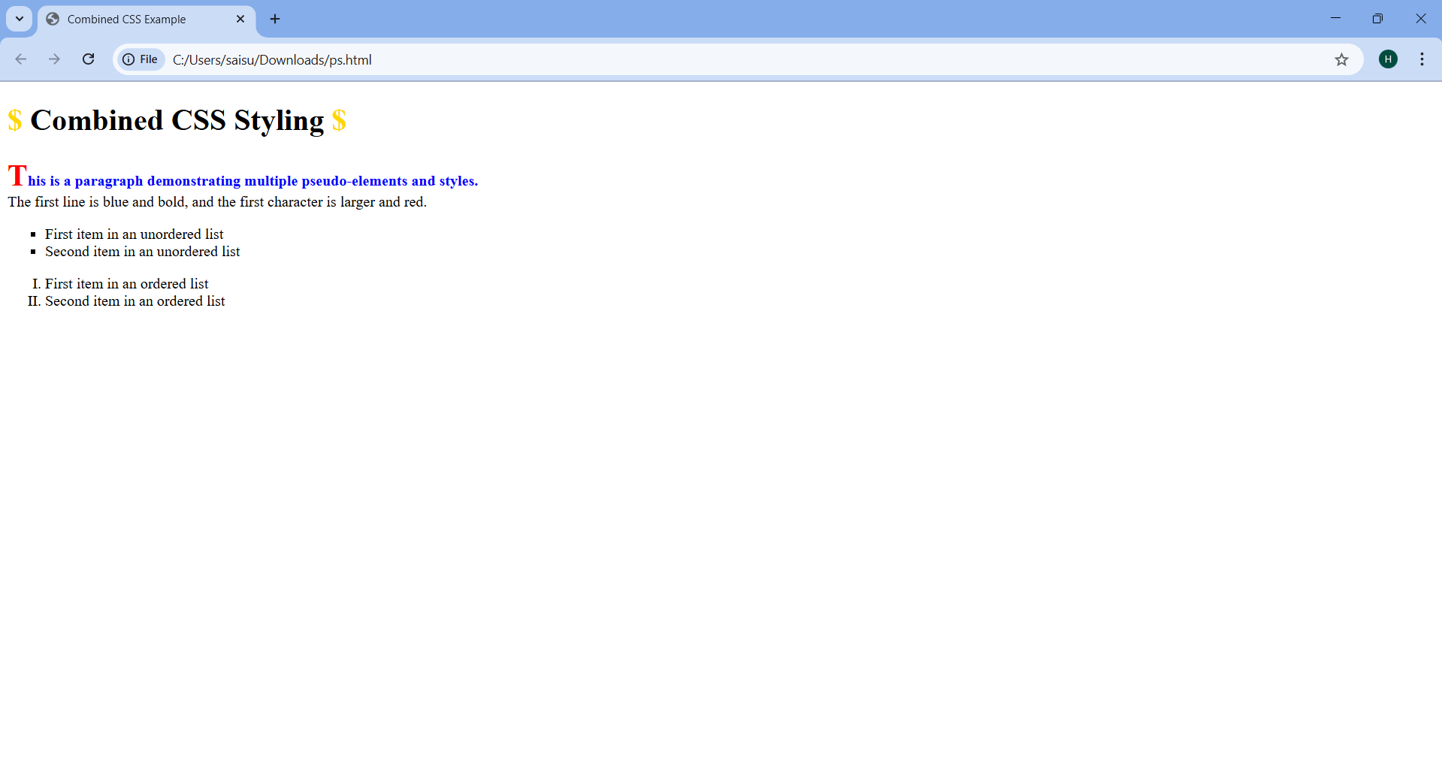

4.5 Attribute selector:

Program:

<!DOCTYPE html>

<html>

<head>

<title>Attribute Selectors Demonstration</title>

<style>

/* Attribute contains a specific word */

[class~="highlight"] {

color:green;

}

/* Attribute starts with */

[href^="https://"] {

color: red;

}

/* Attribute ends with */

[href$=".org"] {

color:aqua;

}

/* Attribute contains a substring */

[href*="example"] {

color: indigo;

}

</style>

</head>

<body>

<h1>CSS Attribute Selectors All-in-One</h1>

<p class="highlight">This paragraph is styled because its class contains the word "highlight".</p>

<a href="https://www.codechef.com/">This link starts with "https://", contains "example", and ends with ".com"</a>

<br>

<a href="https://www.cambridge.org/">This link starts with "https://" and ends with ".org"</a>

<br>

</body>

</html>

Output:

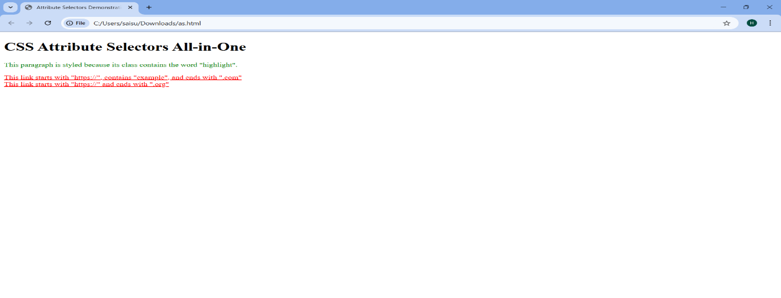

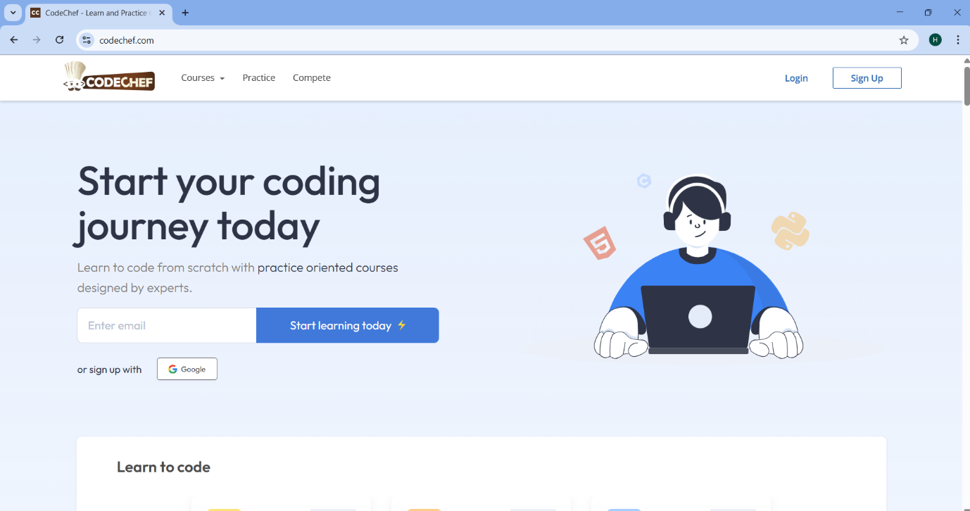

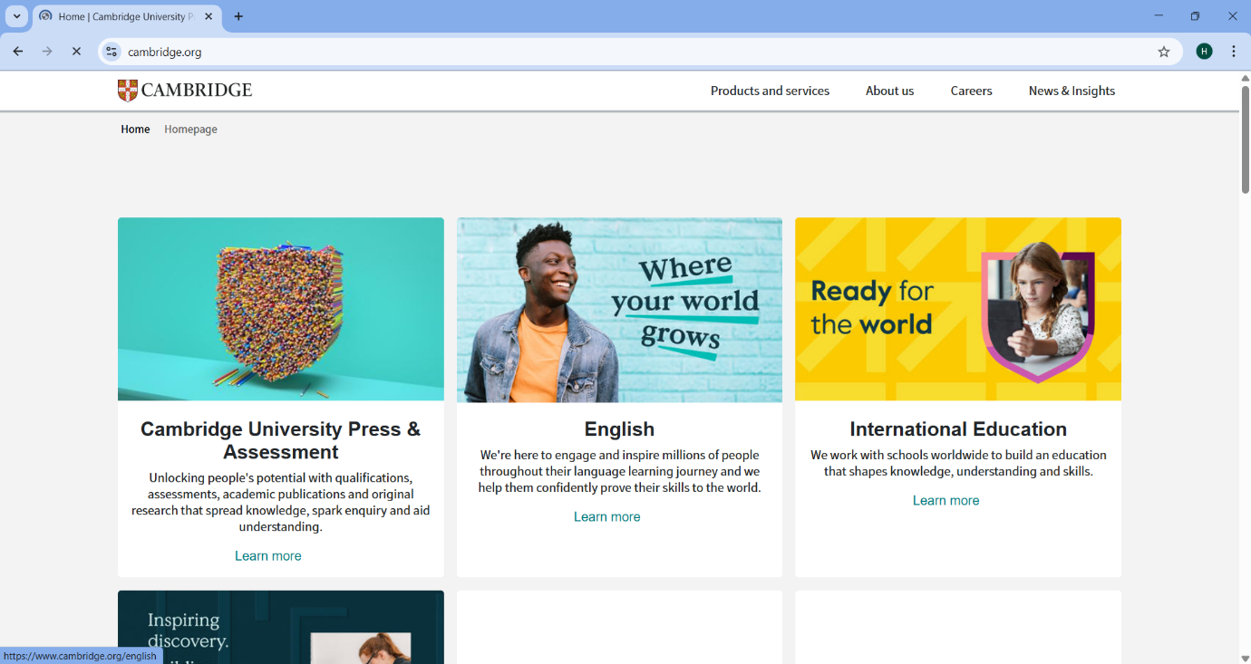

Experiment-5.1: Write a program to demonstrate the various ways you can reference a color in CSS

Program:

<!DOCTYPE html>

<html lang="en">

<head>

<title>CSS Color References</title>

<style>

.color-box {

width: 150px;

height: 50px;

margin: 10px;

text-align: center;

line-height: 50px;

color: white;

font-weight: bold;

}

.hex { background-color: #ff5733; }

.rgb { background-color: rgb(255, 87, 51); }

.hsl { background-color: hsl(9, 100%, 64%); }

</style>

</head>

<body>

<div class="color-box hex">Hex</div>

<div class="color-box rgb">RGB</div>

<div class="color-box hsl">HSL</div>

</body>

</html>

Output:

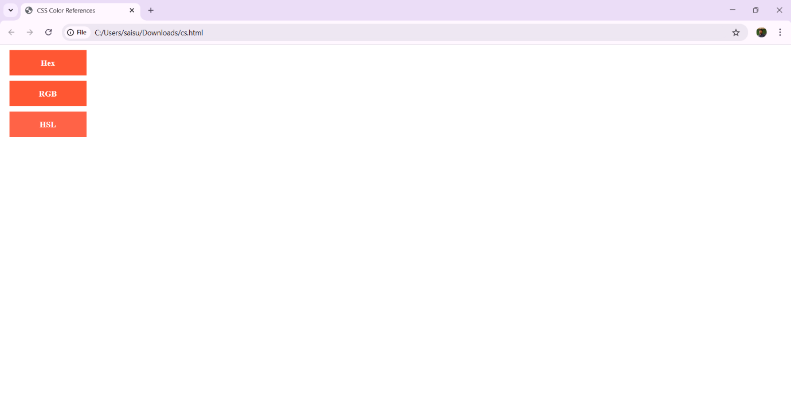

Experiment-5.2: Write a CSS rule that places a background image halfway down the page, tilting it horizontally. The image should remain in place when the user scrolls up or down.

Program:

<!DOCTYPE html>

<html lang="en">

<head>

<title>Fixed Background Image</title>

<style>

body {

margin: 0;

height: 100vh;

background-image: url('s.jpg');

background-position: center 50vh;

background-size: cover;

background-attachment: fixed;

transform: scaleX(-1);

}

.content {

height: 200vh;

display: flex;

align-items: center;

justify-content: center;

font-size: 24px;

}

</style>

</head>

<body>

<div class="content">

Scroll to see the effect!

</div>

</body>

</html>

Output:

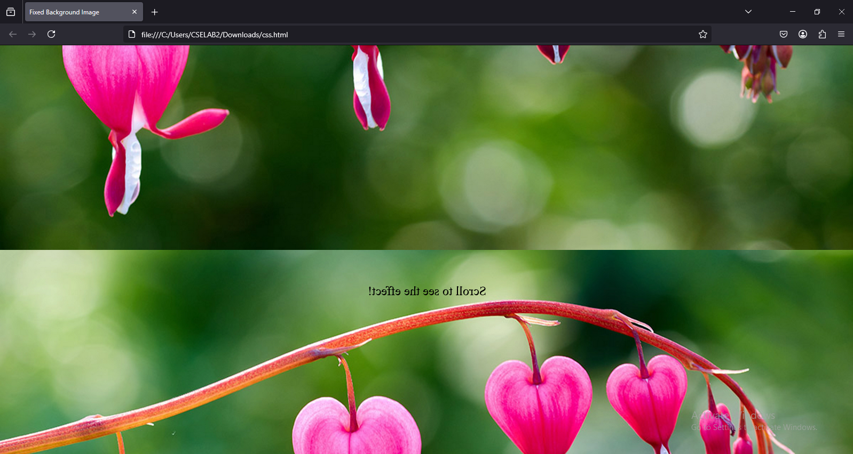

Experiment-5.3: Write a program using the following terms related to CSS font and text: i. font-size ii. font-weight iv. text-decoration v. text-transformation iii. font-style vi. text-alignment

Program:

<!DOCTYPE html>

<html lang="en">

<head>

<title>CSS Font & Text Properties</title>

<style>

body {

font-family: Arial, sans-serif;

text-align: center;

margin: 20px;

}

.styled-text {

font-size: 24px;

font-weight: bold;

font-style: italic;

text-decoration: underline;

text-transform: uppercase;

}

.normal-text {

font-size: 18px;

font-weight: normal;

font-style: normal;

text-decoration: none;

text-transform: lowercase;

text-align: left;

}

</style>

</head>

<body>

<h1>CSS Font & Text Properties Demo</h1>

<p class="styled-text">This text has multiple styles applied.</p>

<p class="normal-text">This is normal text without extra styling.</p>

</body>

</html>

Output:

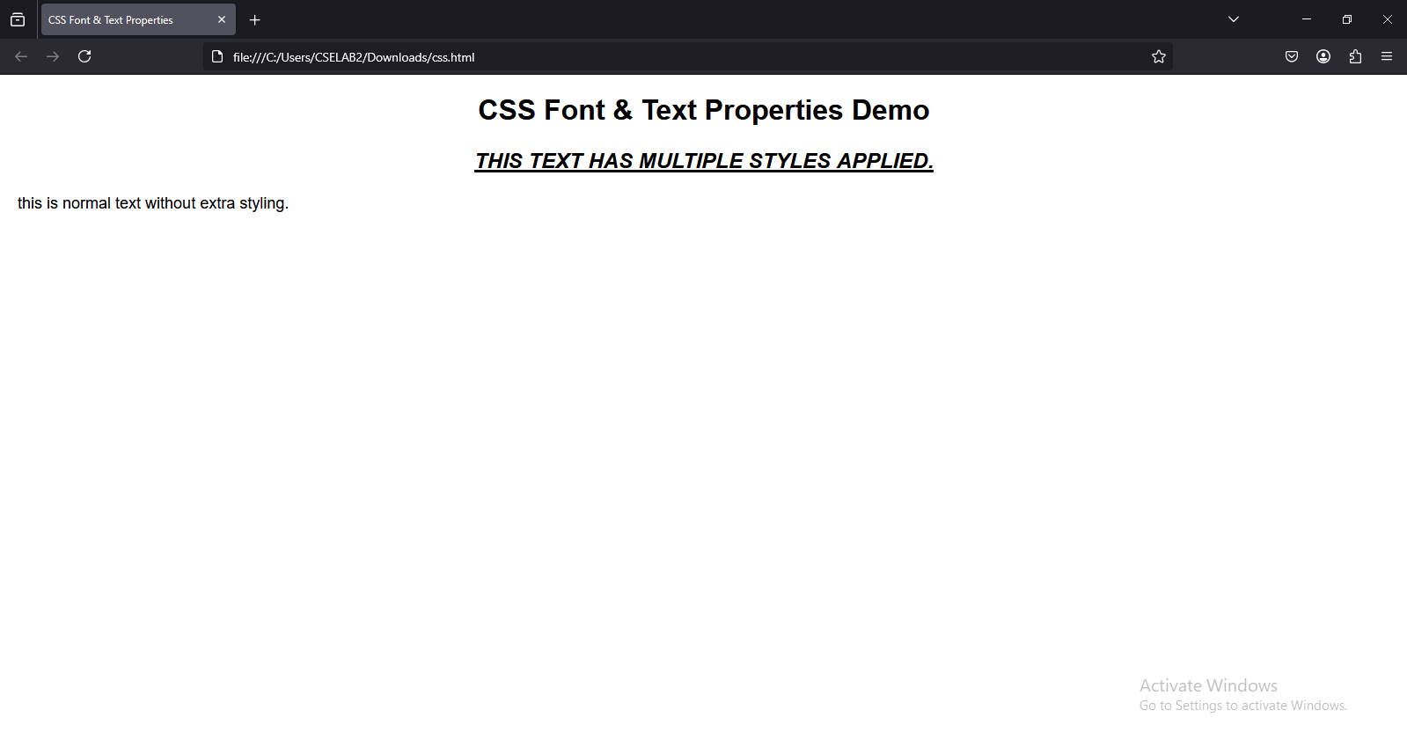

Experiment-5.4: Write a program, to explain the importance of CSS Box model using i. Content ii. Border iii. Margin iv. Padding

Program:

<!DOCTYPE html>

<html lang="en">

<head>

<title>CSS Box Model Demo</title>

<style>

body {

font-family: Arial, sans-serif;

text-align: center;

}

.box {

width: 300px;

background-color: lightblue;

padding: 20px;

border: 5px solid darkblue;

margin: 30px auto;

text-align: left; }

</style>

</head>

<body>

<h1>CSS Box Model Explained</h1>

<div class="box">

<strong>Content:</strong> This is the main content inside the box.<br>

<strong>Padding:</strong> Adds space inside the border.<br>

<strong>Border:</strong> Defines the edge of the box.<br>

<strong>Margin:</strong> Creates space between this box and other elements.

</div>

</body>

</html>

Output:

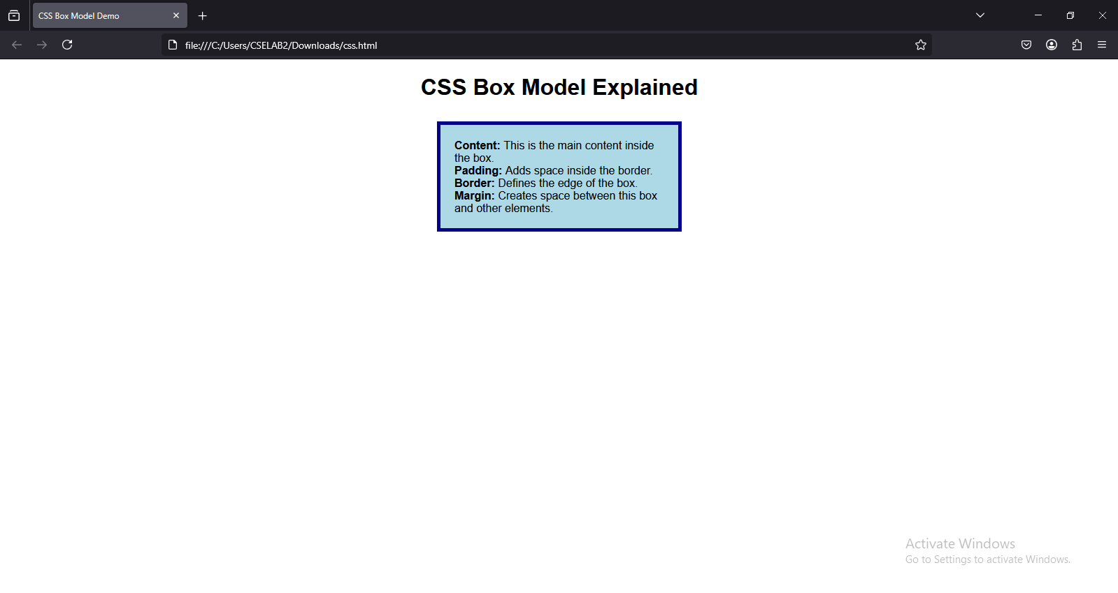

Experiment-6.1: Write a program to embed internal and external JavaScript in a web page.

Program:

<!DOCTYPE html>

<html lang="en">

<head>

<title>Internal and External JavaScript Combined</title>

</head>

<body>

<h1>JavaScript Example</h1>

<button onclick="showMessage()">Click me for Internal JS</button>

<button onclick="externalMessage()">Click me for External JS</button>

<!-- Internal JavaScript -->

<script>

// This is internal JavaScript

function showMessage() {

alert("Hello from Internal JavaScript!");

}

</script>

<!-- External JavaScript -->

<script>

// This is external JavaScript code placed here inside the HTML file

function externalMessage() {

alert("Hello from External JavaScript!");

}

</script>

</body>

</html>

Output:

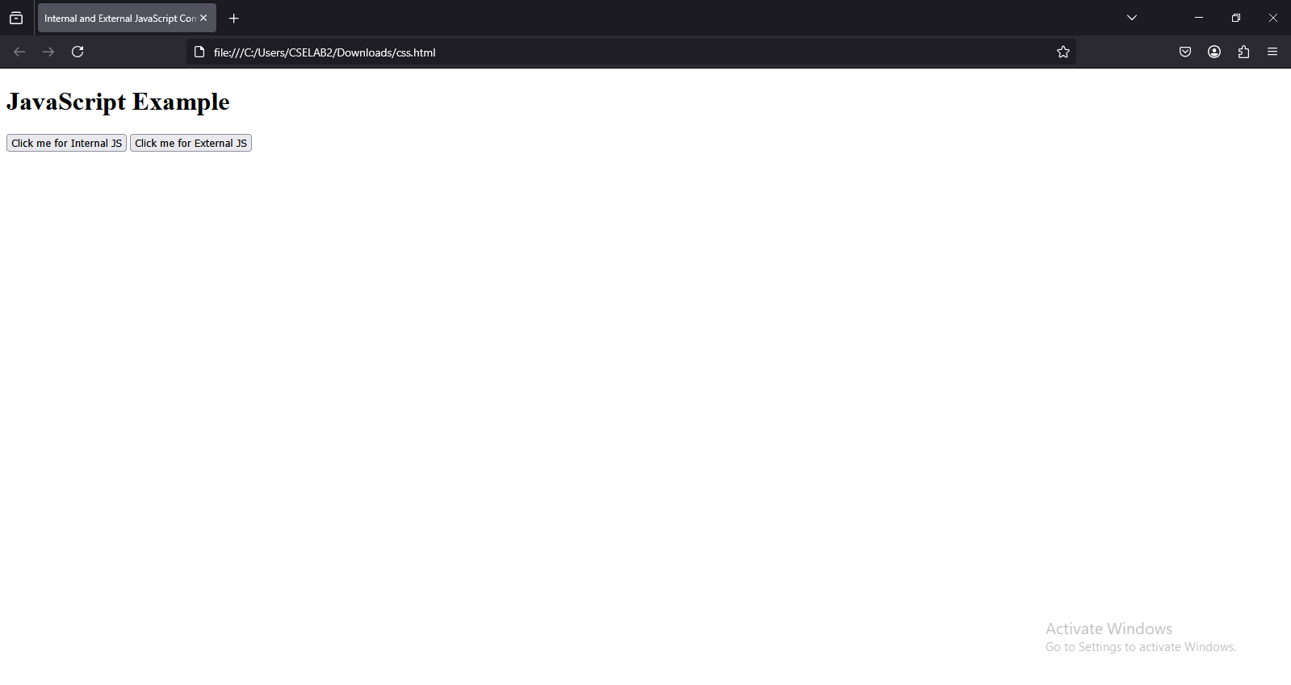

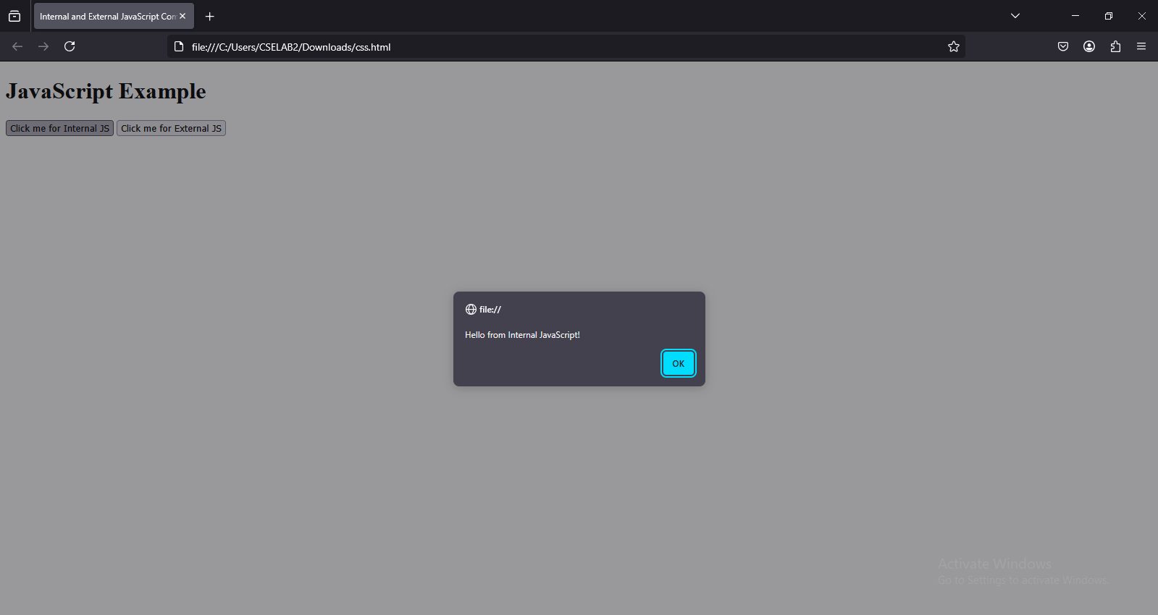

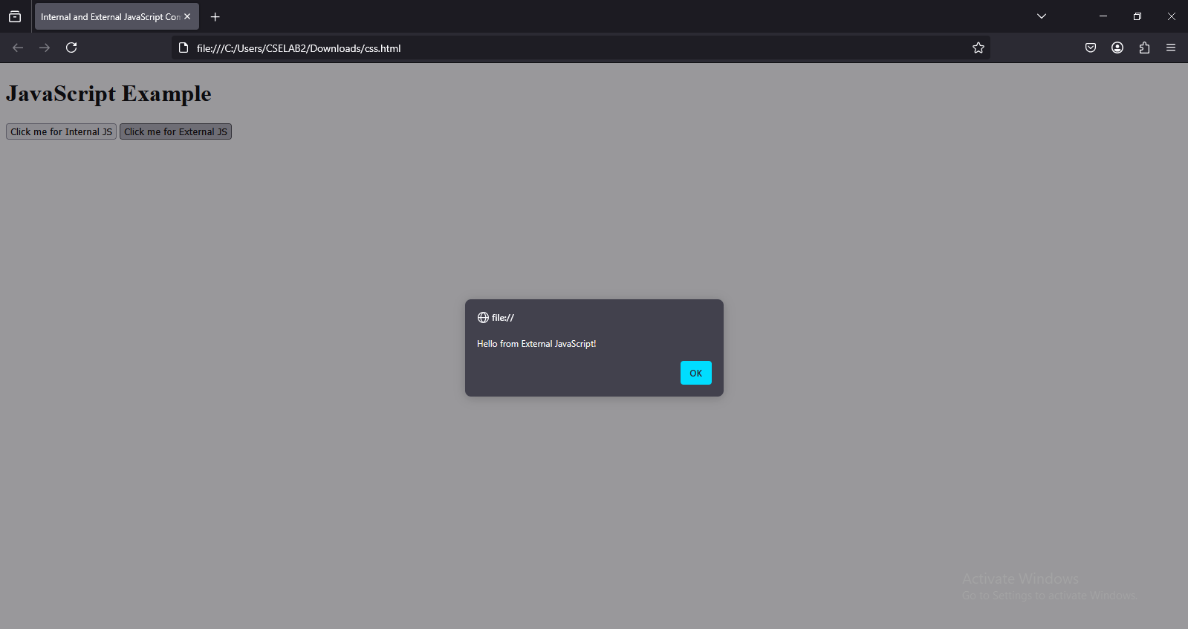

Experiment-6.2: Write a program to explain the different ways for displaying output.

Program:

<!DOCTYPE html>

<html lang="en">

<head>

<title>JavaScript Output Methods</title>

<script>

// 1. Using document.write()

document.write("<h3>Output using document.write()</h3>");

// 2. Using console.log()

console.log("This is an output in the browser console.");

// 3. Using alert()

function showAlert() {

alert("This is an alert box!");

}

// 4. Using innerHTML

function changeInnerHTML() {

document.getElementById("output").innerHTML = "Output changed using innerHTML!";

}

// 5. Using innerText

function changeInnerText() {

document.getElementById("textOutput").innerText = "Text changed using innerText!";

}

</script>

</head>

<body>

<h1>JavaScript Output Methods</h1>

<button onclick="showAlert()">Show Alert</button>

<button onclick="changeInnerHTML()">Change innerHTML</button>

<button onclick="changeInnerText()">Change innerText</button>

<p id="output">This is a paragraph. Click the button to change its content using innerHTML.</p>

<p id="textOutput">This is another paragraph. Click the button to change its text using innerText.</p>

</body>

</html>

Output:

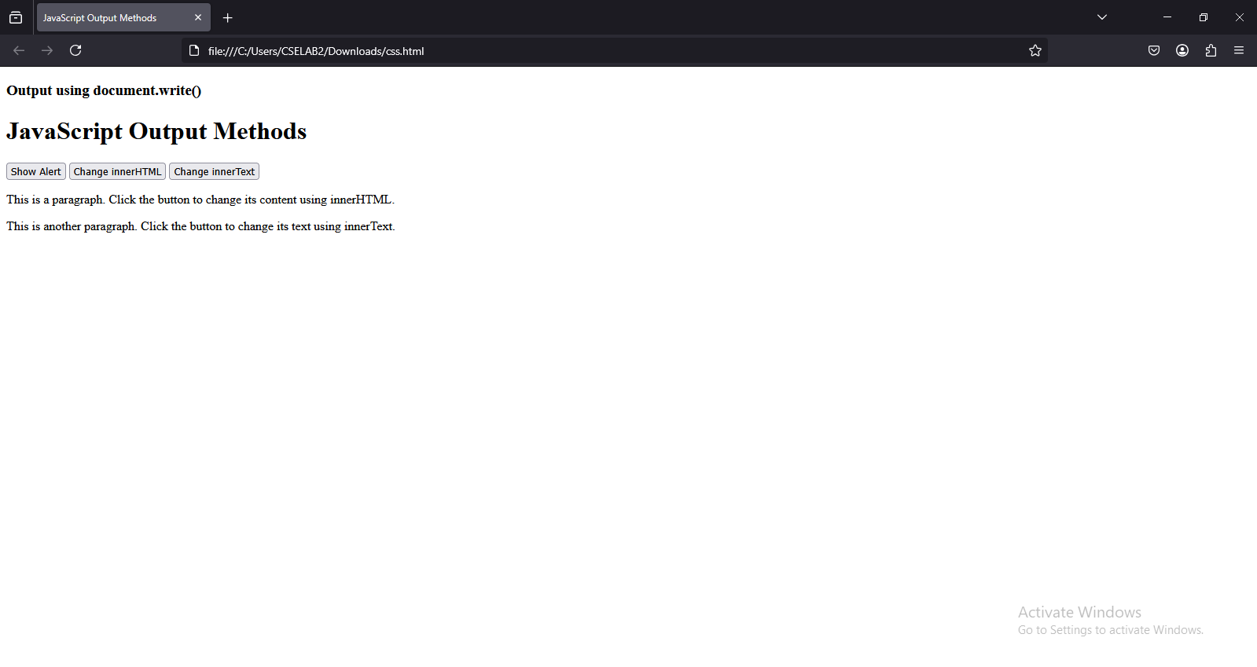

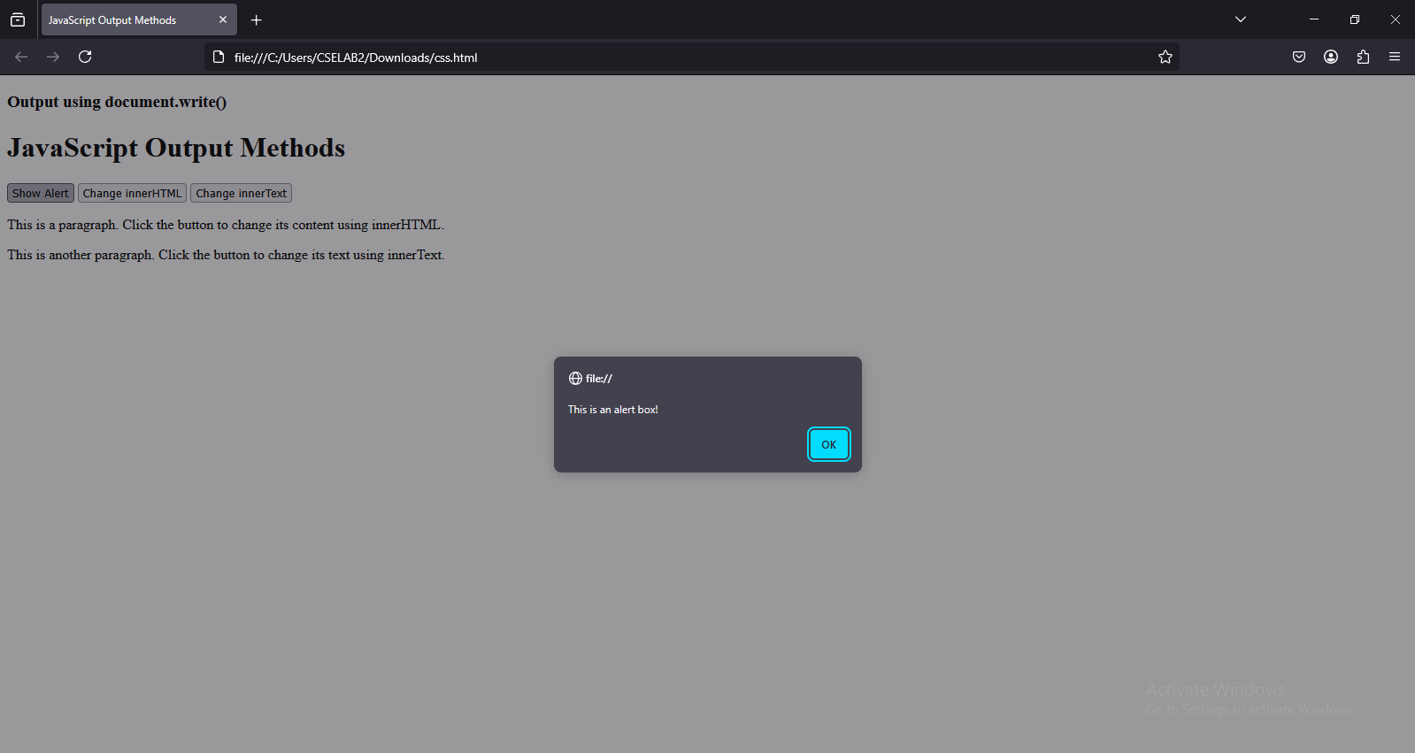

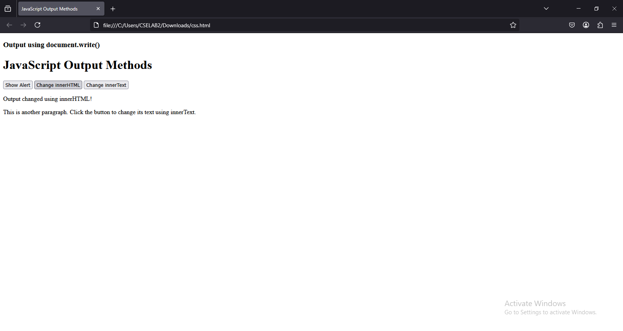

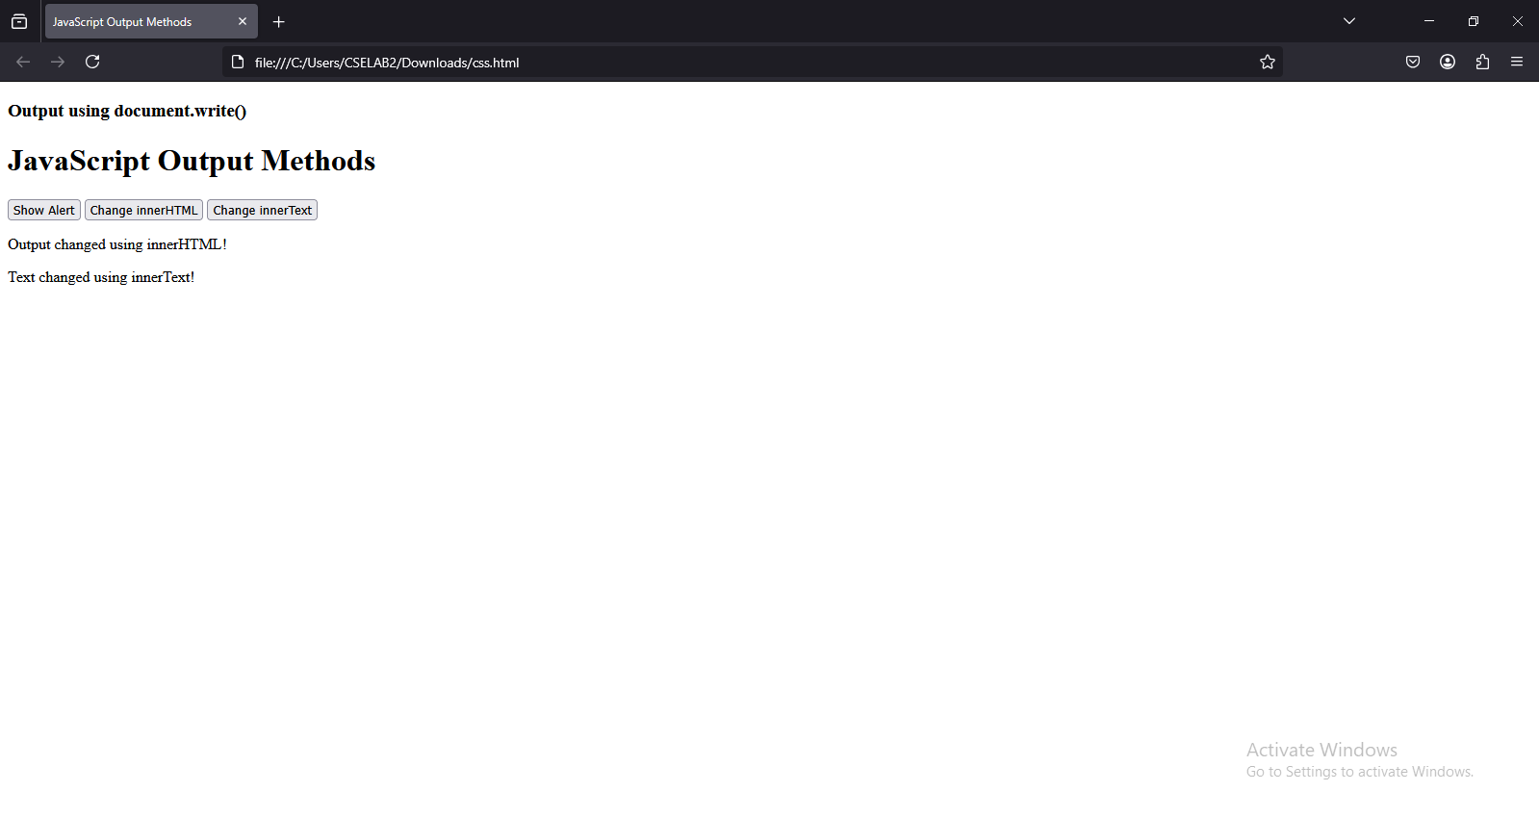

Experiment-6.3: Write a program to explain the different ways for taking input.

Program:

<!DOCTYPE html>

<html lang="en">

<head>

<title>JavaScript Input Methods</title>

<script>

// 1. Taking input using prompt()

function getPromptInput() {

let name = prompt("Enter your name:");

if (name) {

document.getElementById("promptOutput").innerText = "Hello, " + name + "!";

}

}

// 2. Taking input using HTML form

function getFormInput() {

let inputValue = document.getElementById("formInput").value;

document.getElementById("formOutput").innerText = "You entered: " + inputValue;

}

// 3. Taking input using confirm()

function getConfirmInput() {

let response = confirm("Do you like JavaScript?");

document.getElementById("confirmOutput").innerText = response ? "You like JavaScript!" : "You don't like JavaScript.";

}

// 4. Taking input using event listener (keypress)

function detectKey(event) {

document.getElementById("keyOutput").innerText = "You pressed: " + event.key;

}

</script>

</head>

<body>

<h1>JavaScript Input Methods</h1>

<!-- 1. Using Prompt -->

<button onclick="getPromptInput()">Enter Name (Prompt)</button>

<p id="promptOutput"></p>

<!-- 2. Using Form Input -->

<input type="text" id="formInput" placeholder="Type something">

<button onclick="getFormInput()">Submit</button>

<p id="formOutput"></p>

<!-- 3. Using Confirm -->

<button onclick="getConfirmInput()">Confirm Example</button>

<p id="confirmOutput"></p>

<!-- 4. Using Key Event -->

<p>Press any key in the box below:</p>

<input type="text" onkeypress="detectKey(event)">

<p id="keyOutput"></p>

</body>

</html>

Output:

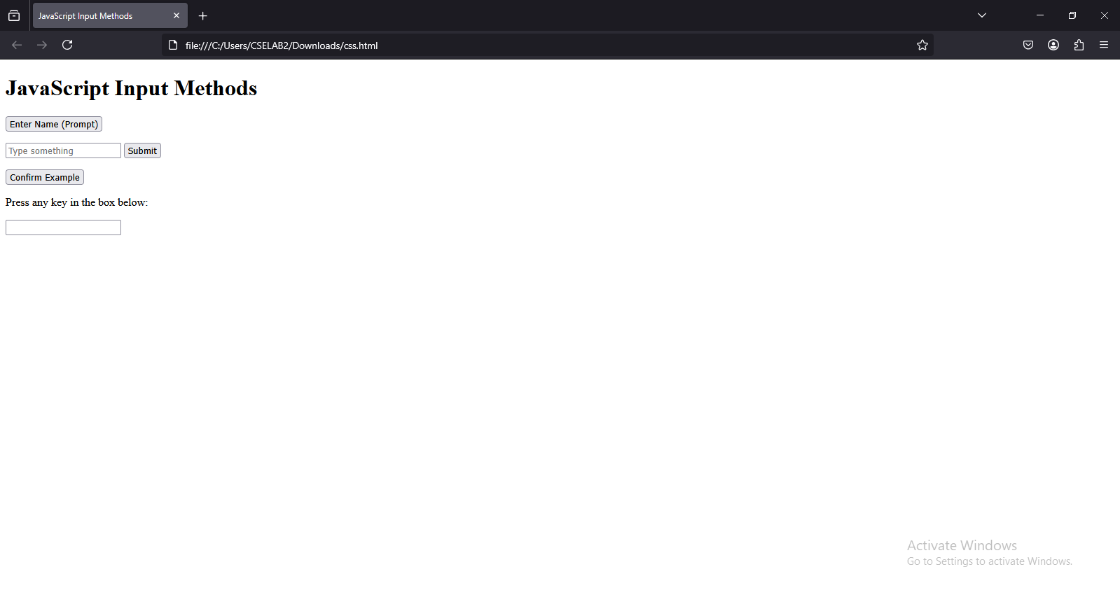

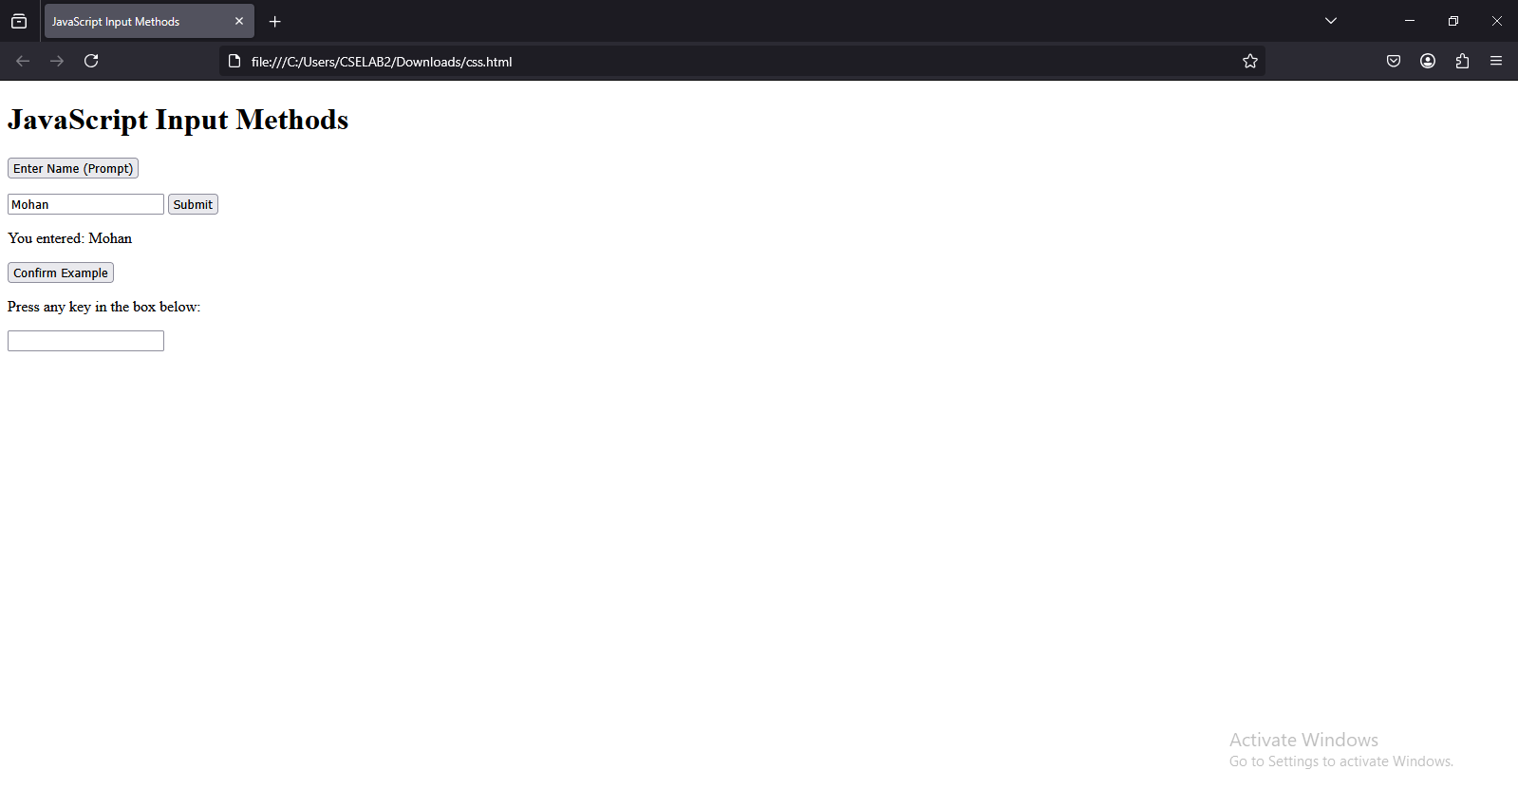

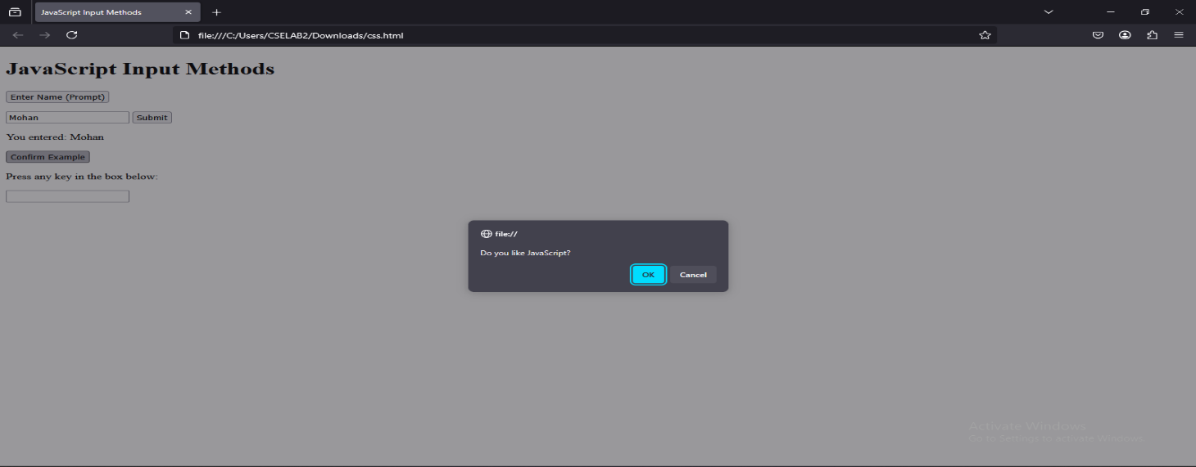

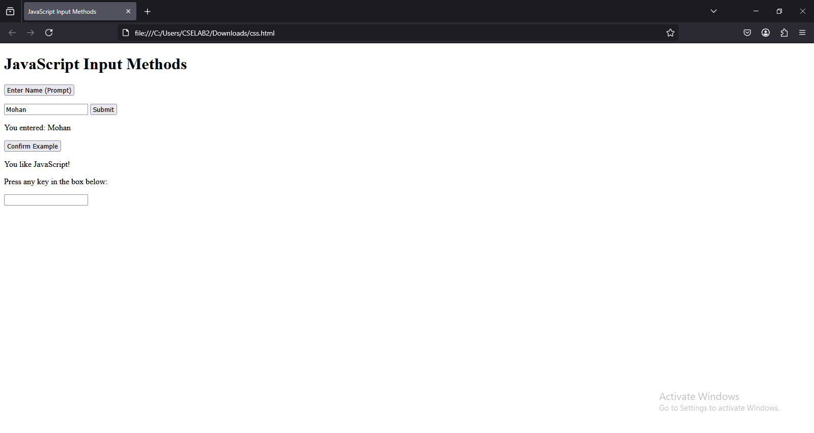

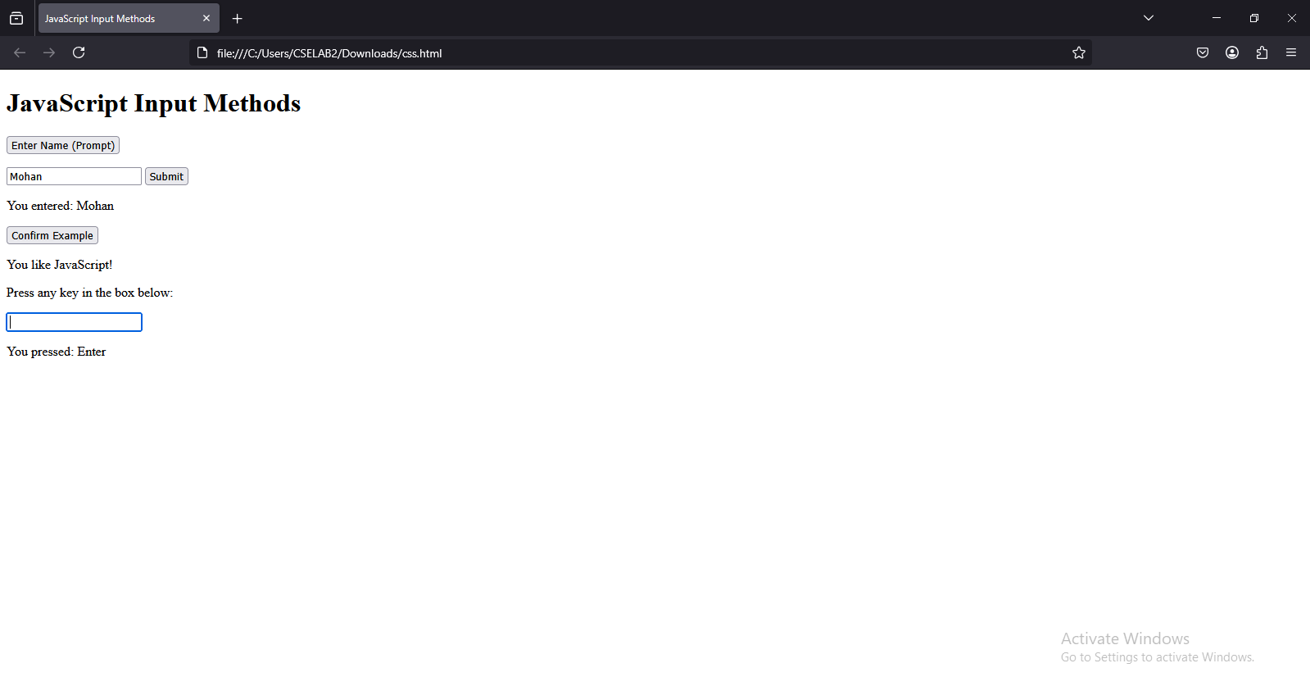

Experiment-6.4: Create a webpage which uses prompt dialogue box to ask a voter for his name and age. Display the information in table format along with either the voter can vote or not.

Program:

<!DOCTYPE html>

<html lang="en">

<head>

<title>Voter Eligibility Check</title>

<style>

body {

font-family: Arial, sans-serif;

text-align: center;

margin: 20px;

}

table {

width: 50%;

margin: auto;

border-collapse: collapse;

}

th, td {

border: 1px solid black;

padding: 10px;

}

th {

background-color: lightblue;

}

</style>

<script>

function getVoterDetails() {

let name = prompt("Enter your name:");

let age = prompt("Enter your age:");

if (name && age) {

age = parseInt(age);

let eligibility = (age >= 18) ? "Can Vote" : "Cannot Vote";

// Insert data into the table

document.getElementById("voterName").innerText = name;

document.getElementById("voterAge").innerText = age;

document.getElementById("voterEligibility").innerText = eligibility;

} else {

alert("Please enter both name and age.");

}

}

</script>

</head>

<body onload="getVoterDetails()">

<h1>Voter Eligibility Check</h1>

<table>

<tr>

<th>Name</th>

<th>Age</th>

<th>Eligibility</th>

</tr>

<tr>

<td id="voterName"></td>

<td id="voterAge"></td>

<td id="voterEligibility"></td>

</tr>

</table>

</body>

</html>

Output:

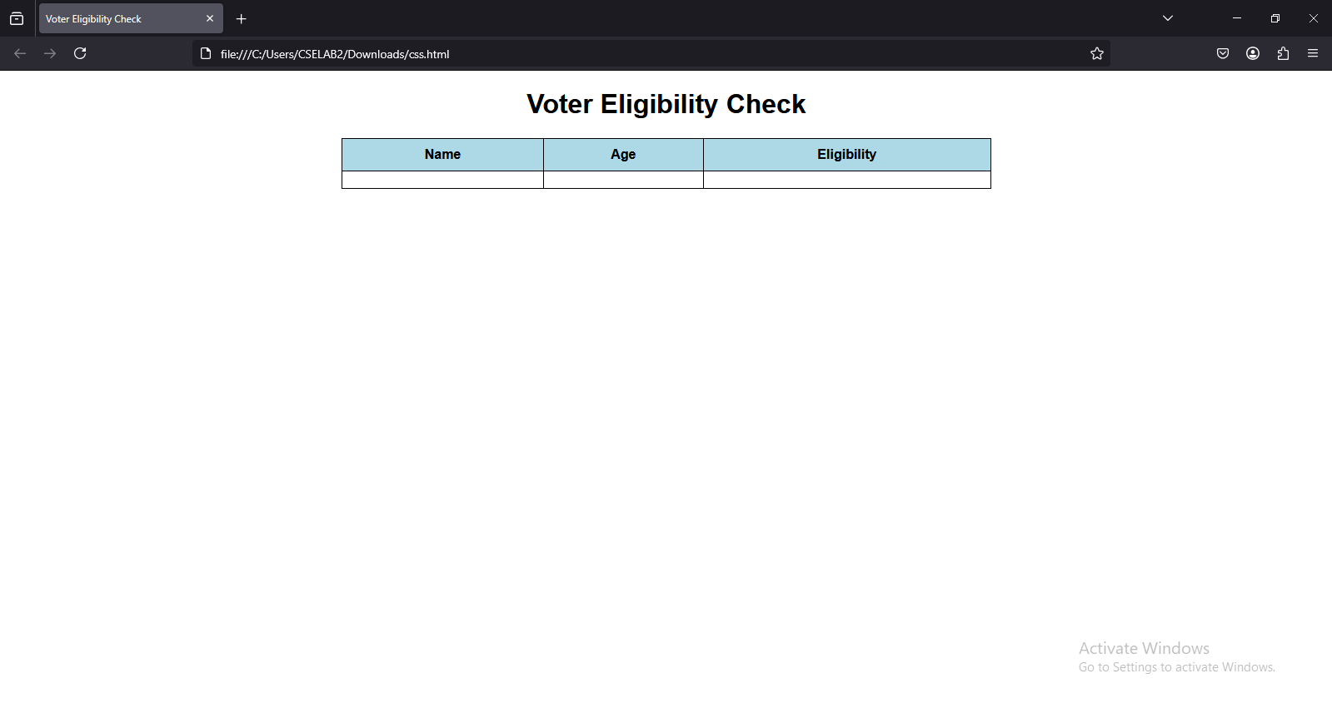

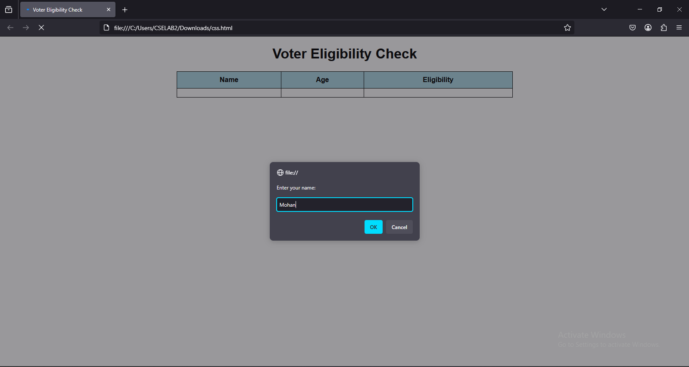

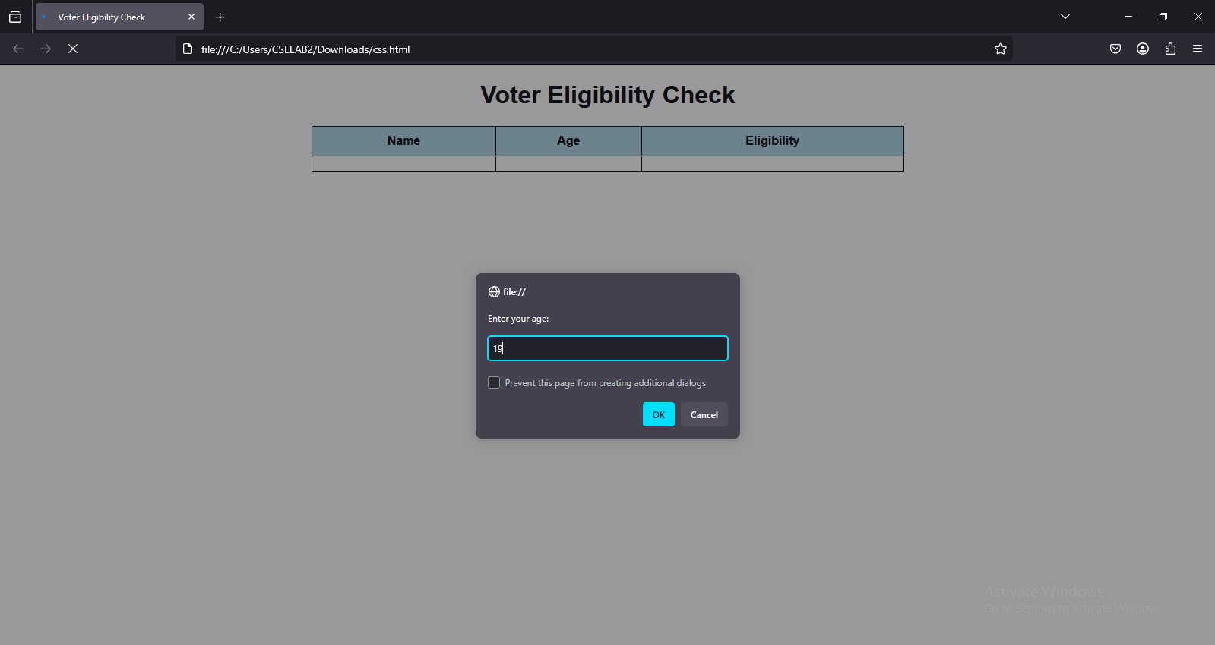

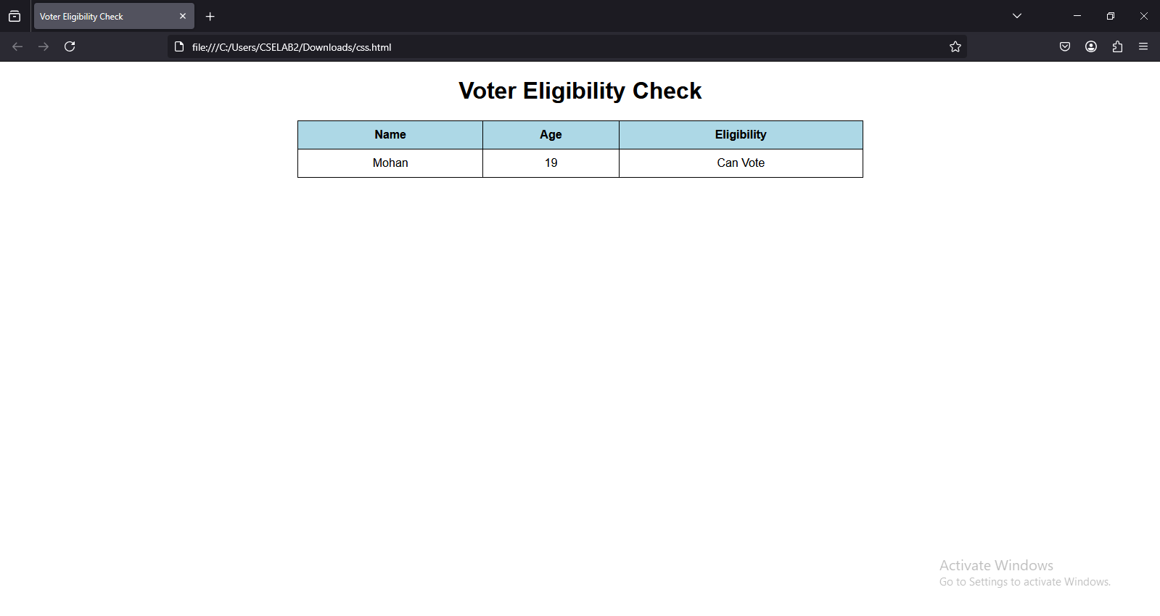

Experiment-7.1: Write a program using document object properties and methods.

Program:

<!DOCTYPE html>

<html lang="en">

<head>

<meta charset="UTF-8">

<meta name="viewport" content="width=device-width, initial-scale=1.0">

<title>Document Object Example</title>

</head>

<body>

<h2 id="text">Hello, World!</h2>

<button onclick="changeText()">Change Text</button>

<button onclick="changeBgColor()">Change Background</button>

<button onclick="addParagraph()">Add Paragraph</button>

<script>

function changeText() {

document.getElementById("text").innerText = "Text Changed!";

}

function changeBgColor() {

document.body.style.backgroundColor = "#f4a261"; // Changing background color

}

function addParagraph() {

let newPara = document.createElement("p"); // Create a new paragraph

newPara.innerText = "This is a new paragraph added dynamically!";

document.body.appendChild(newPara); // Append it to the body

}

</script>

</body>

</html>

Output:

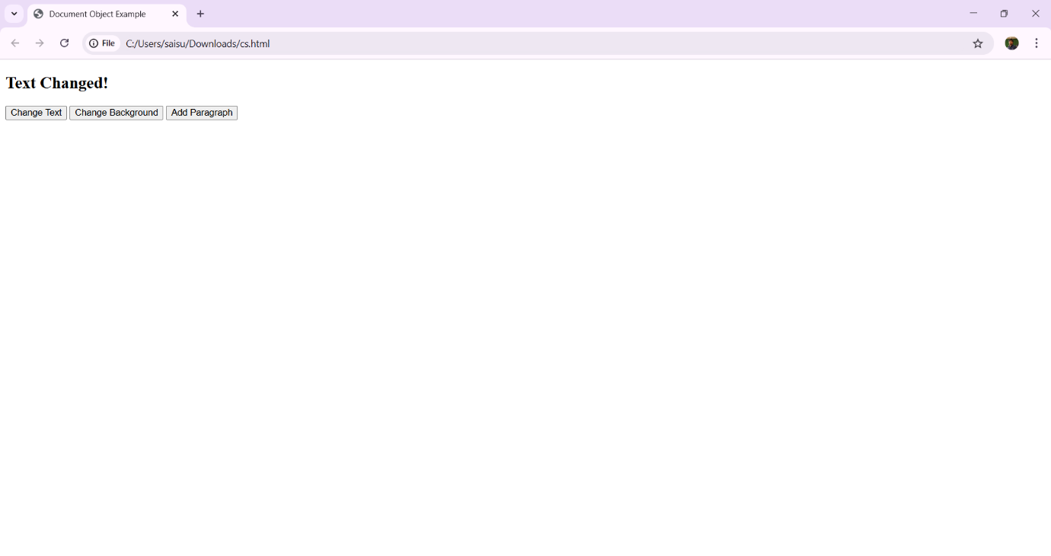

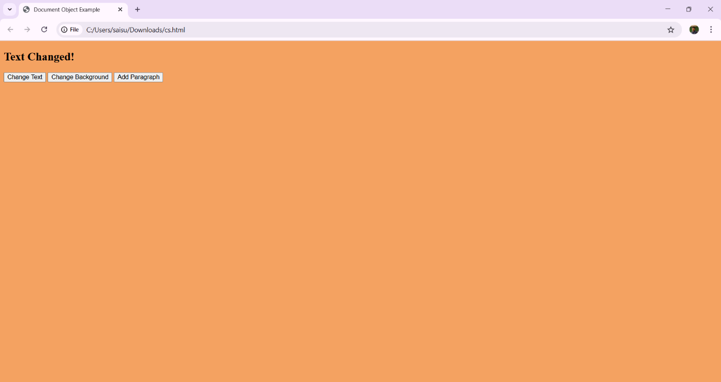

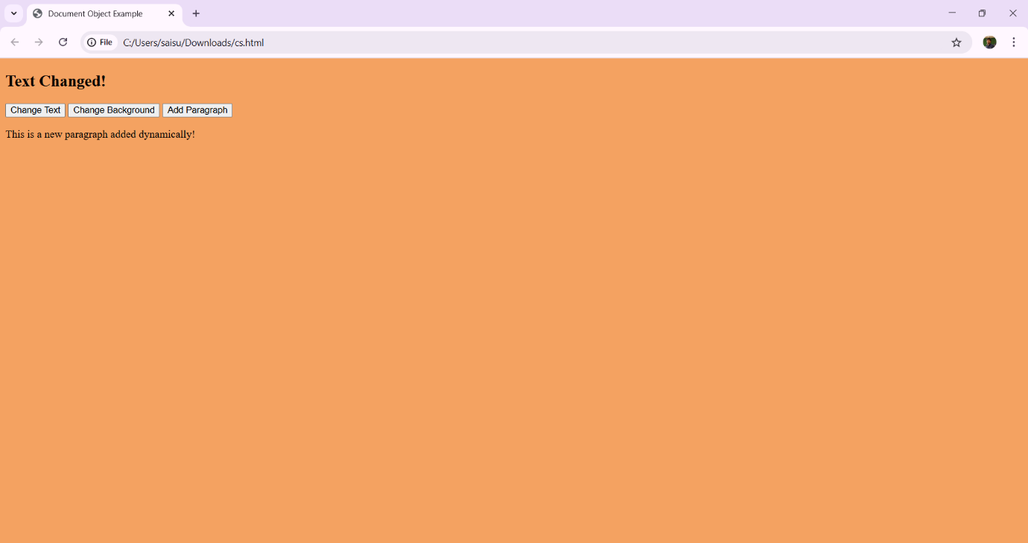



Experiment-7.2: Write a program using window object properties and methods.

Program:

<!DOCTYPE html>

<html lang="en">

<head>

<title>Window Object Example</title>

</head>

<body>

<button onclick="showAlert()">Click Me</button>

<script>

function showAlert() {

window.alert("Hello! This is a window alert.");

}

</script>

</body>

</html>

Output:

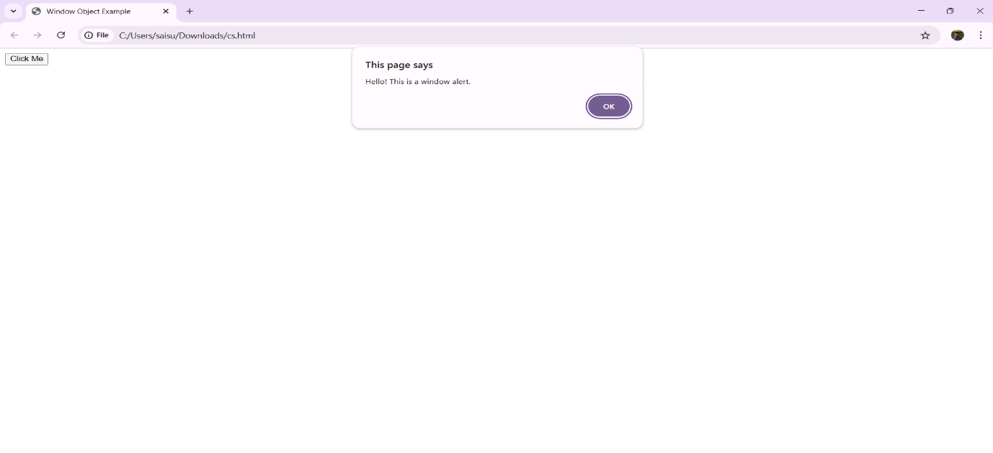

Experiment-7.3: Write a program using array object properties and methods.

Program:

<!DOCTYPE html>

<html lang="en">

<head>

<title>Array Object Example</title>

</head>

<body>

<h2>Array Example</h2>

<button onclick="addItem()">Add Item</button>

<button onclick="removeItem()">Remove Item</button>

<h3 id="output"></h3>

<script>

let items = ["Apple", "Banana", "Cherry"]; // Array with initial values

function addItem() {

items.push("Orange"); // Add an item

document.getElementById("output").innerText = items.join(", ");

}

function removeItem() {

items.pop(); // Remove last item

document.getElementById("output").innerText = items.join(", ");

}

</script>

</body>

</html>

Output:

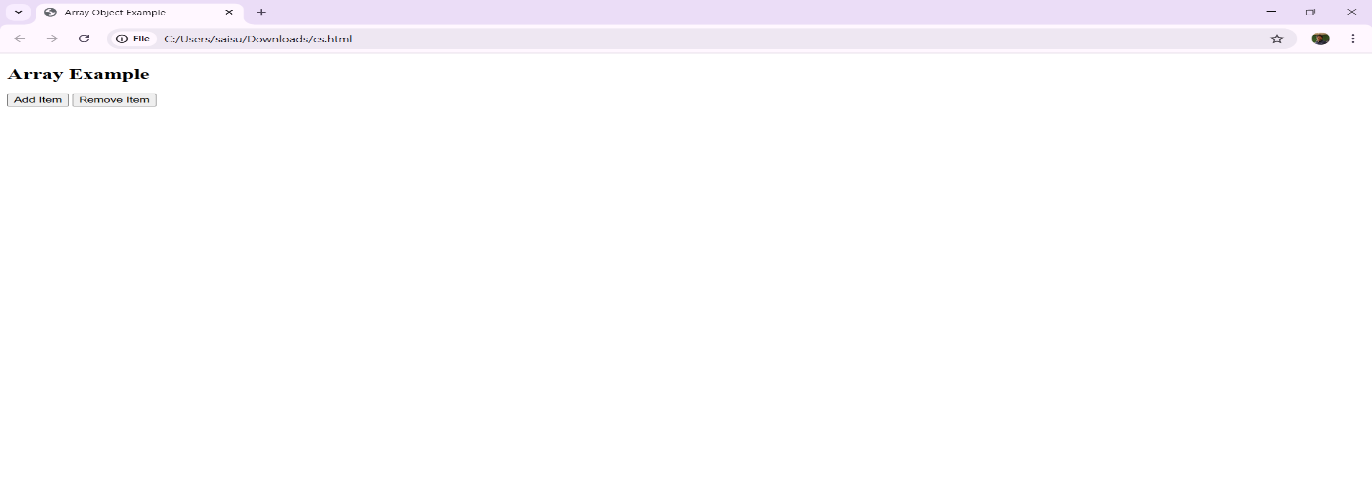

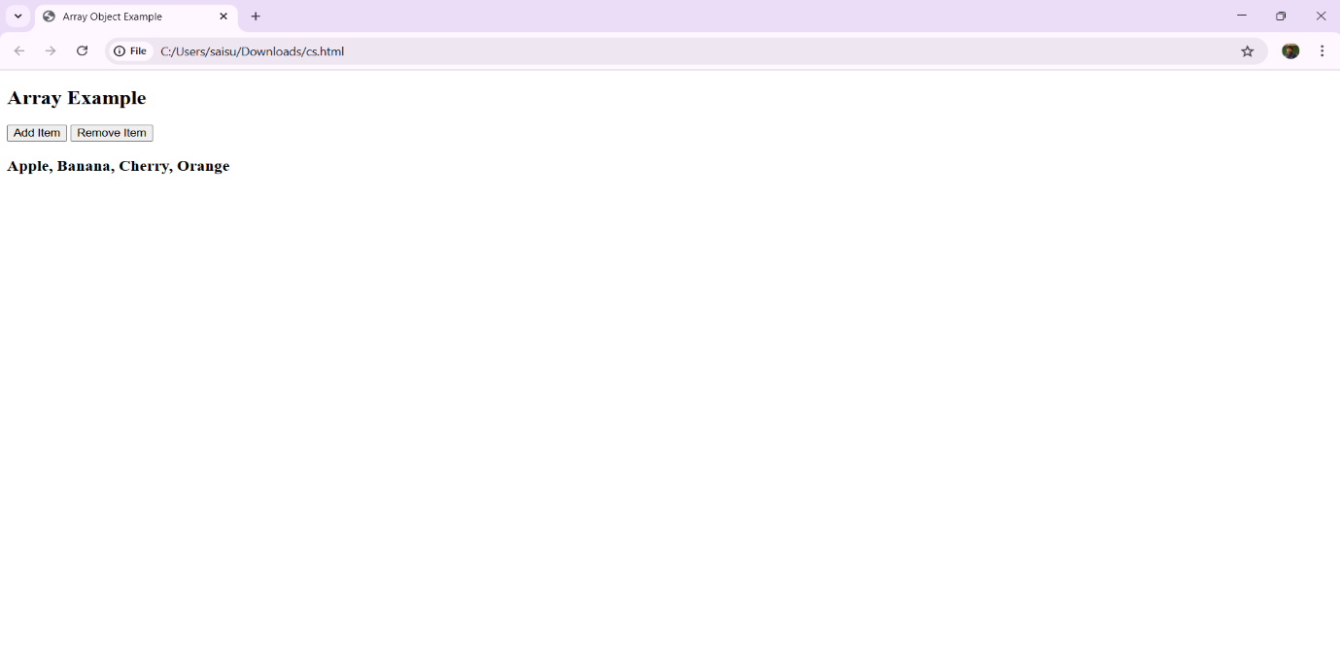

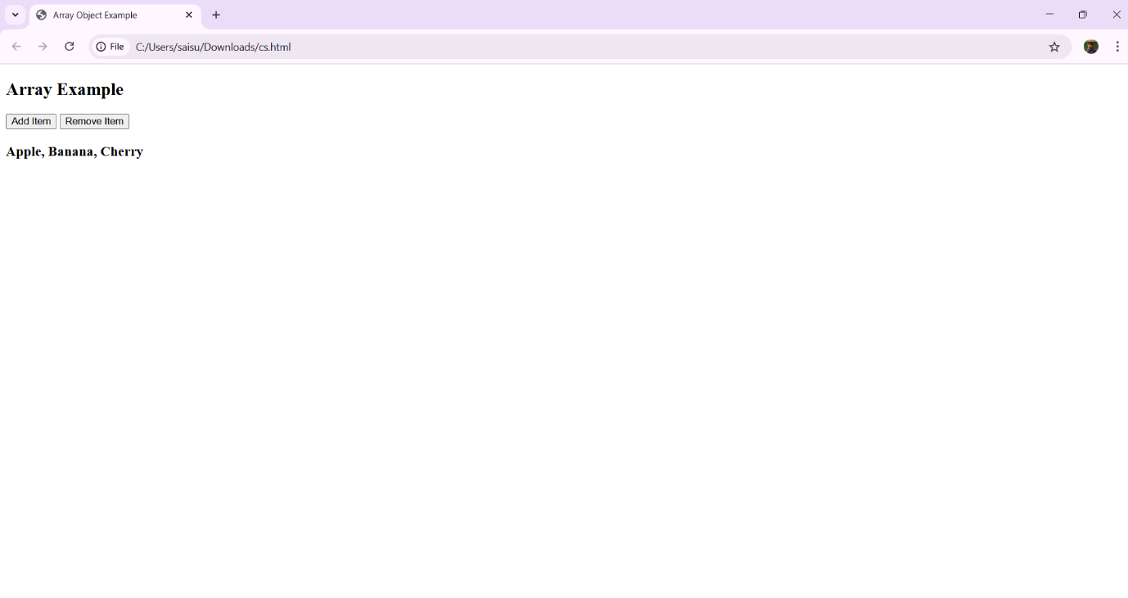

Experiment-7.4: Write a program using math object properties and methods.

Program:

<!DOCTYPE html>

<html lang="en">

<head>

<title>Math Object Example</title>

</head>

<body>

<h2>Math Object Demo</h2>

<button onclick="generateNumber()">Generate Random Number</button>

<h3 id="output"></h3>

<script>

function generateNumber() {

let num = Math.floor(Math.random() * 100) + 1; // Random number from 1 to 100

let sqrt = Math.sqrt(num); // Square root

let rounded = Math.round(sqrt); // Rounded value

document.getElementById("output").innerHTML =

`Random Number: ${num} <br> Square Root: ${sqrt} <br> Rounded: ${rounded}`;

}

</script>

</body>

</html>

Output:

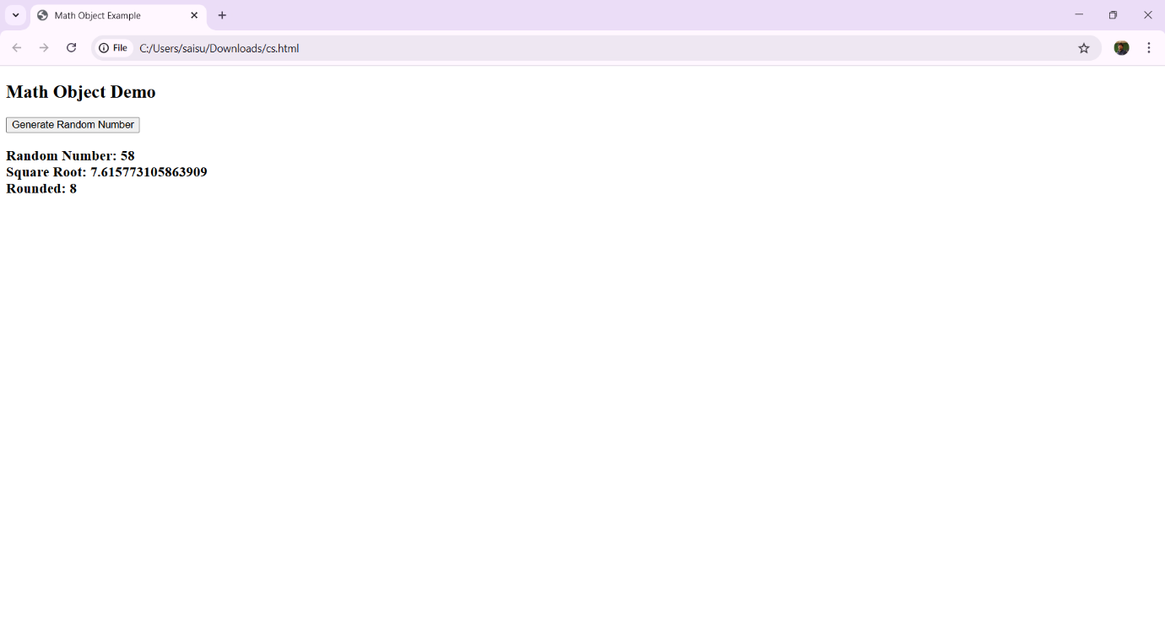

Experiment-7.5: Write a program using string object properties and methods.

Program: <!DOCTYPE html>

<html lang="en">

<head>

<title>String Object Example</title>

</head>

<body>

<h2>String Example</h2>

<input type="text" id="textInput" placeholder="Enter text">

<button onclick="convertText()">Convert to Uppercase</button>

<h3 id="output"></h3>

<script>

function convertText() {

let text = document.getElementById("textInput").value;

document.getElementById("output").innerText = text.toUpperCase();

}

</script>

</body>

</html>

Output:

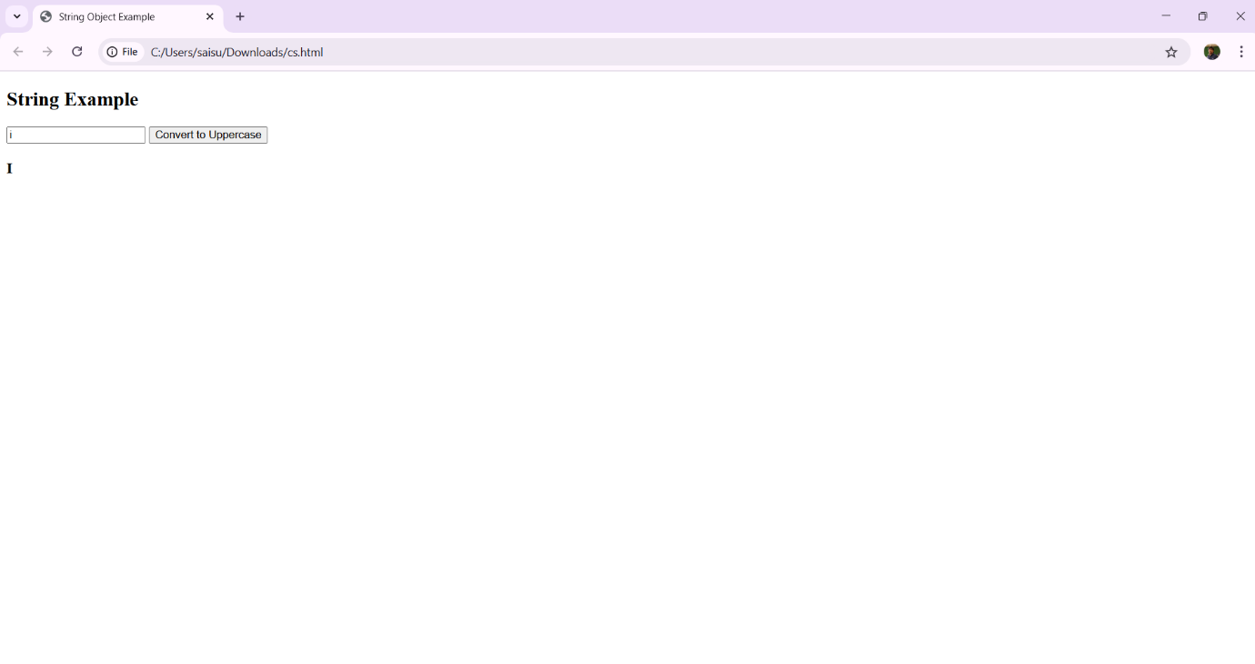

Experiment-7.6: Write a program using regex object properties and methods.

Program:

<!DOCTYPE html>

<html lang="en">

<head>

<title>Regex Example</title>

</head>

<body>

<h2>Number Checker</h2>

<input type="text" id="textInput" placeholder="Enter something">

<button onclick="checkNumbers()">Check</button>

<h3 id="output"></h3>

<script>

function checkNumbers() {

let text = document.getElementById("textInput").value;

let pattern = /^[0-9]+$/; // Regex for only numbers

if (pattern.test(text)) {

document.getElementById("output").innerText = " Only numbers!";

} else {

document.getElementById("output").innerText = " Contains non-numeric characters!";

}

}

</script>

</body>

</html>

Output:

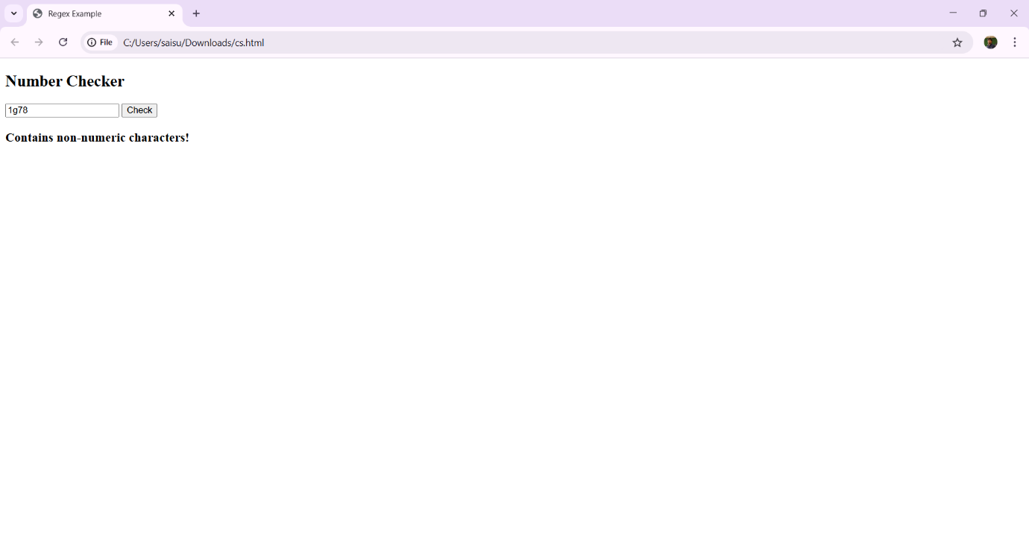

Experiment-7.7: Write a program using date object properties and methods.

Program:

<!DOCTYPE html>

<html lang="en">

<head>

<title>Date Object Example</title>

</head>

<body>

<h2>Current Date & Time</h2>

<button onclick="showDateTime()">Show Date & Time</button>

<h3 id="output"></h3>

<script>

function showDateTime() {

let now = new Date(); // Create a Date object

let dateTime = now.toLocaleString(); // Get formatted date & time

document.getElementById("output").innerText = "📅 " + dateTime;

}

</script>

</body>

</html>

Output:

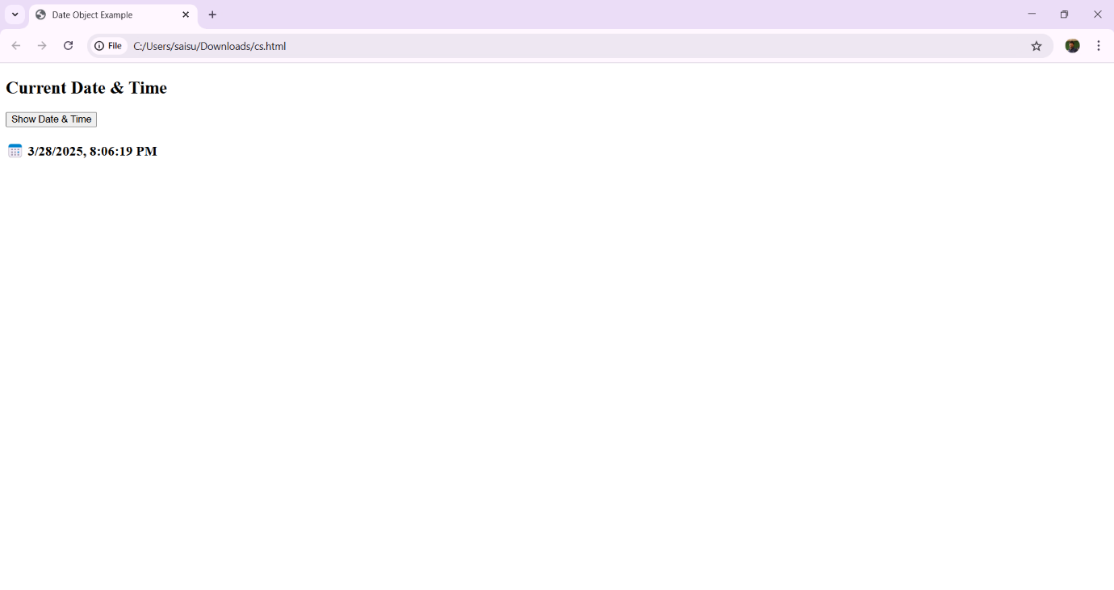

Experiment-7.8: Write a program to explain user-defined object by using properties, methods, accessors, constructors and display

Program:

<!DOCTYPE html>

<html lang="en">

<head>

<title>User-Defined Object Example</title>

</head>

<body>

<h2>Simple User Object</h2>

<button onclick="showPerson()">Create Person</button>

<h3 id="output"></h3>

<script>

// Constructor function for Person

function Person(name, age) {

this.name = name;

this.age = age;

// Method to display person details

this.getInfo = function() {

return `Name: ${this.name}, Age: ${this.age}`;

};

}

function showPerson() {

let user = new Person("Alice", 25); // Creating an object

document.getElementById("output").innerText = user.getInfo();

}

</script>

</body>

</html>

Output:

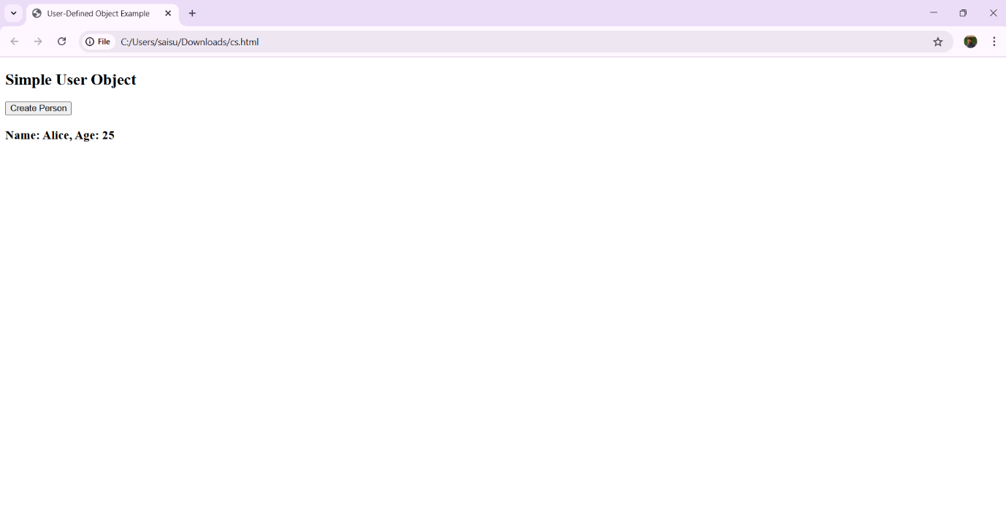

Experiment-8.1: Write a program which asks the user to enter three integers, obtains the numbers from the user and outputs HTML text that displays the larger number followed by the words “LARGER NUMBER” in an information message dialog. If the numbers are equal, output HTML text as “EQUAL NUMBERS”.

Program:

<!DOCTYPE html>

<html lang="en">

<head>

<title>Find the Largest Number</title>

</head>

<body>

<h2>Enter Three Numbers</h2>

<label>Number 1: </label><input type="number" id="num1"><br><br>

<label>Number 2: </label><input type="number" id="num2"><br><br>

<label>Number 3: </label><input type="number" id="num3"><br><br>

<button onclick="findLargest()">Find Largest</button>

<h3 id="output"></h3>

<script>

function findLargest() {

// Get values from input fields

let n1 = parseInt(document.getElementById("num1").value);

let n2 = parseInt(document.getElementById("num2").value);

let n3 = parseInt(document.getElementById("num3").value);

let message = "";

// Check if numbers are equal

if (n1 === n2 && n2 === n3) {

message = "EQUAL NUMBERS";

} else {

let largest = Math.max(n1, n2, n3);

message = `${largest} - LARGER NUMBER`;

}

// Display result in an alert and on the page

alert(message);

document.getElementById("output").innerText = message;

}

</script>

</body>

</html>

Output:

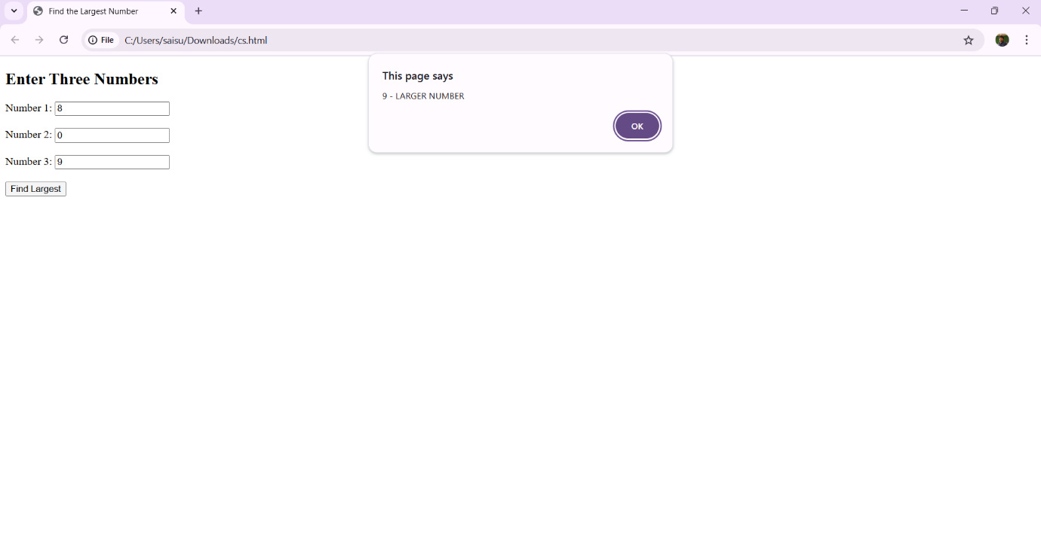

Experiment-8.2: Write a program to display week days using switch case.

Program:

<!DOCTYPE html>

<html lang="en">

<head>

<title>Weekday Finder</title>

</head>

<body>

<h2>Enter a Number (1-7) to Get the Day of the Week</h2>

<input type="number" id="dayInput" min="1" max="7">

<button onclick="findWeekday()">Find Day</button>

<h3 id="output"></h3>

<script>

function findWeekday() {

let dayNumber = parseInt(document.getElementById("dayInput").value);

let dayName;

switch (dayNumber) {

case 1:

dayName = "Sunday";

break;

case 2:

dayName = "Monday";

break;

case 3:

dayName = "Tuesday";

break;

case 4:

dayName = "Wednesday";

break;

case 5:

dayName = "Thursday";

break;

case 6:

dayName = "Friday";

break;

case 7:

dayName = "Saturday";

break;

default:

dayName = "Invalid Input! Please enter a number between 1 and 7.";

}

document.getElementById("output").innerText = dayName;

}

</script>

</body>

</html>

Output:

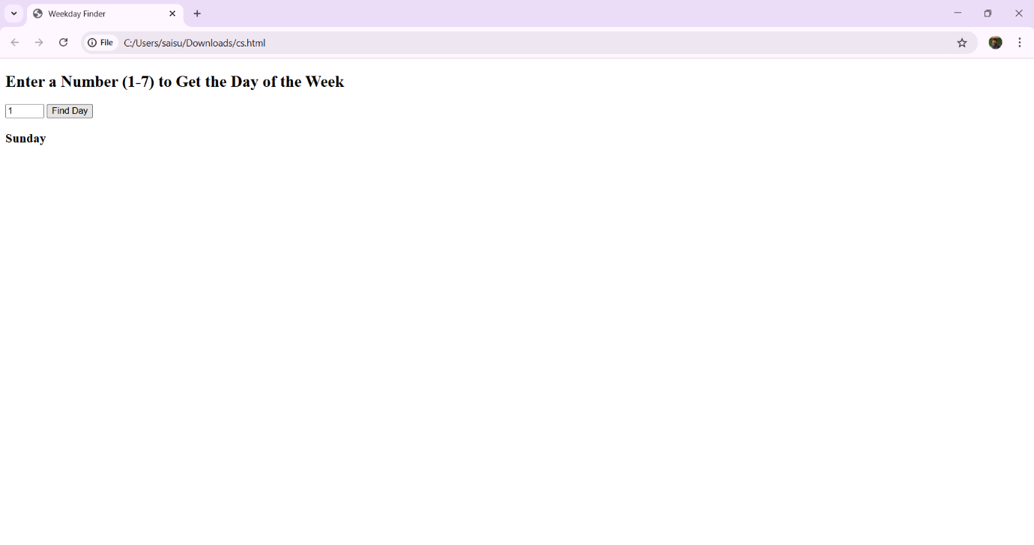

Experiment-8.3: Write a program to print 1 to 10 numbers using for, while and do-while loops.

Program:

<!DOCTYPE html>

<html lang="en">

<head>

<title>Loop Examples</title>

</head>

<body>

<h2>Print Numbers 1 to 10 Using Different Loops</h2>

<button onclick="printForLoop()">For Loop</button>

<button onclick="printWhileLoop()">While Loop</button>

<button onclick="printDoWhileLoop()">Do-While Loop</button>

<h3 id="output"></h3>

<script>

function printForLoop() {

let result = "For Loop: ";

for (let i = 1; i <= 10; i++) {

result += i + " ";

}

document.getElementById("output").innerText = result;

}

function printWhileLoop() {

let result = "While Loop: ";

let i = 1;

while (i <= 10) {

result += i + " ";

i++;

}

document.getElementById("output").innerText = result;

}

function printDoWhileLoop() {

let result = "Do-While Loop: ";

let i = 1;

do {

result += i + " ";

i++;

} while (i <= 10);

document.getElementById("output").innerText = result;

}

</script>

</body>

</html>

Output:

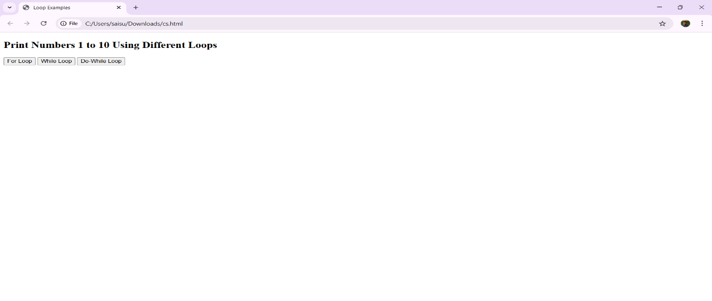

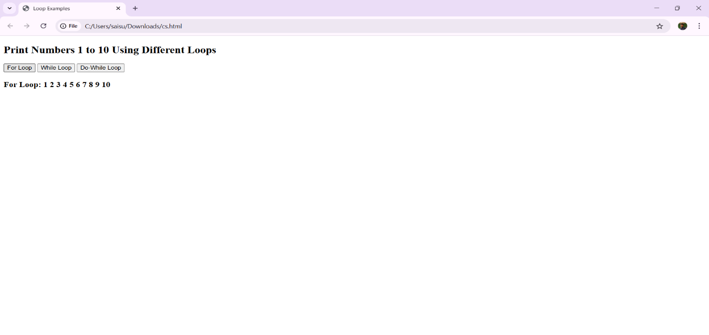

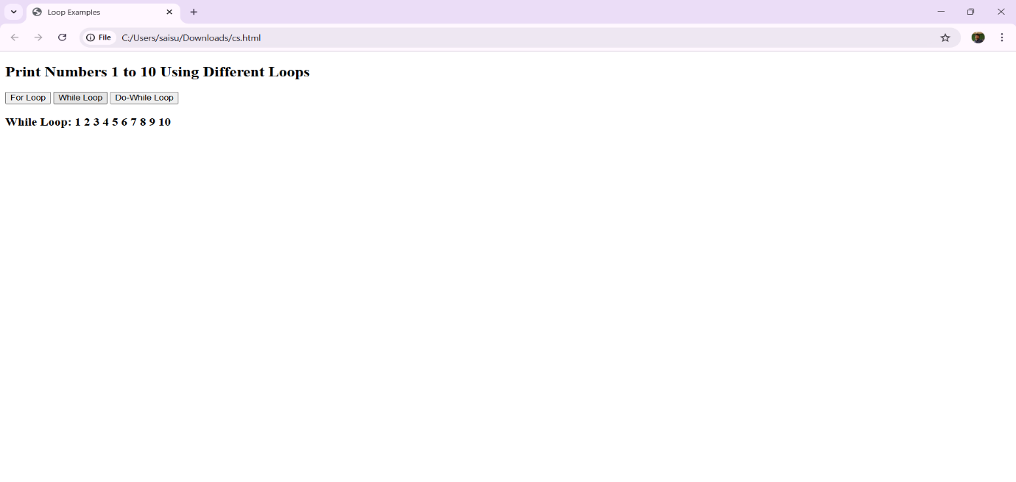

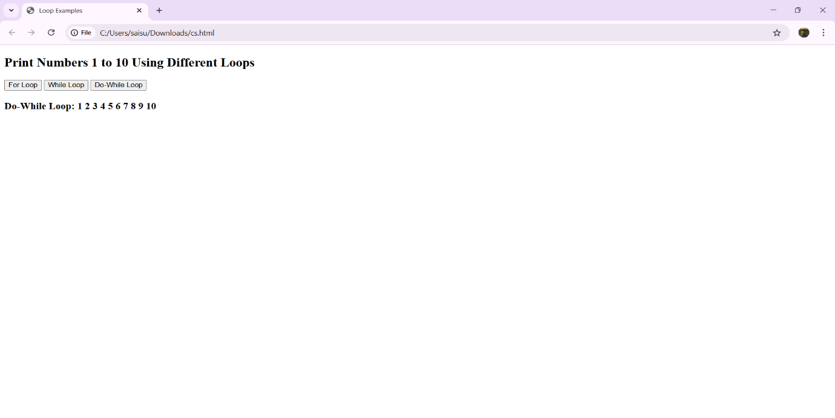

Experiment-8.4: Write aprogram to print data in object using for-in, for-each and for-of loops.

Program:

<!DOCTYPE html>

<html lang="en">

<head>

<title>Loop Through Object</title>

</head>

<body>

<h2>Loop Through Object Data</h2>

<button onclick="printForIn()">For-In Loop</button>

<button onclick="printForEach()">ForEach Loop</button>

<button onclick="printForOf()">For-Of Loop</button>

<h3 id="output"></h3>

<script>

// Sample Object

let person = {

name: "Alice",

age: 25,

country: "USA",

hobbies: ["Reading", "Traveling", "Gaming"]

};

// For-In Loop: Iterates over object properties

function printForIn() {

let result = "For-In Loop:\n";

for (let key in person) {

result += `${key}: ${person[key]}\n`;

}

document.getElementById("output").innerText = result;

}

// ForEach Loop: Iterates over an array inside the object

function printForEach() {

let result = "ForEach Loop (Hobbies):\n";

person.hobbies.forEach((hobby, index) => {

result += `${index + 1}. ${hobby}\n`;

});

document.getElementById("output").innerText = result;

}

// For-Of Loop: Iterates over an array inside the object

function printForOf() {

let result = "For-Of Loop (Hobbies):\n";

for (let hobby of person.hobbies) {

result += `${hobby}\n`;

}

document.getElementById("output").innerText = result;

}

</script>

</body>

</html>

Output:

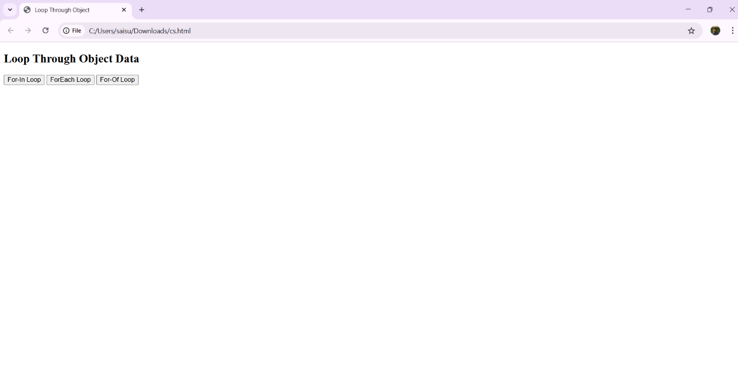

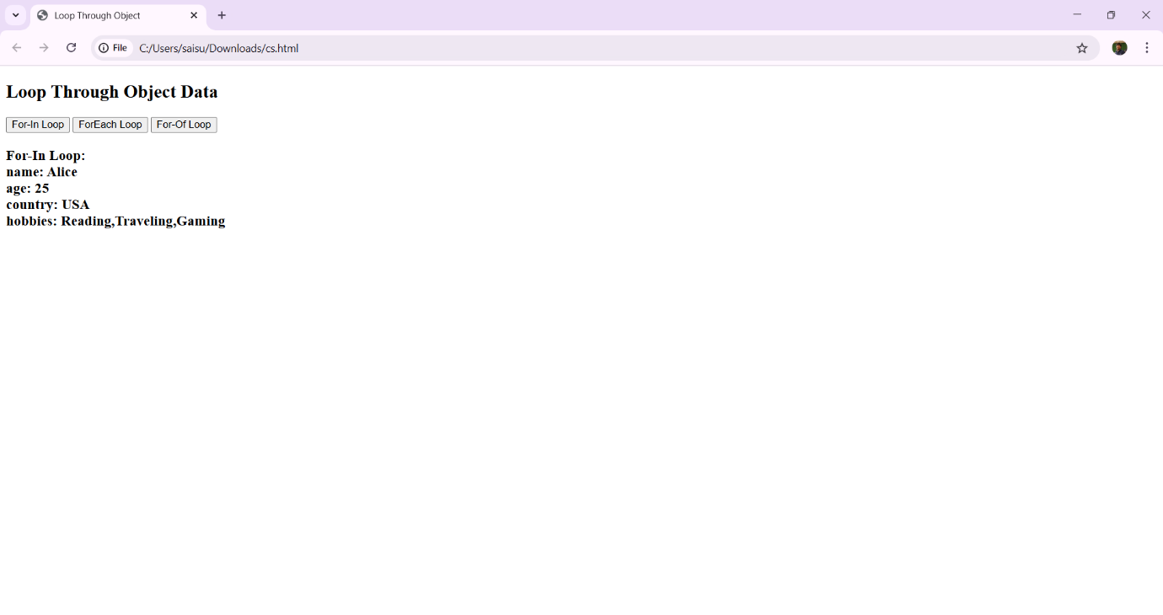

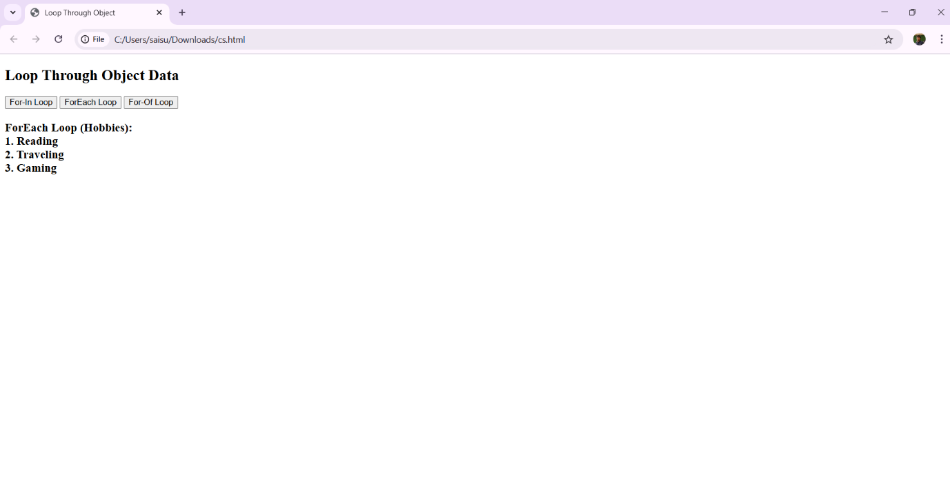

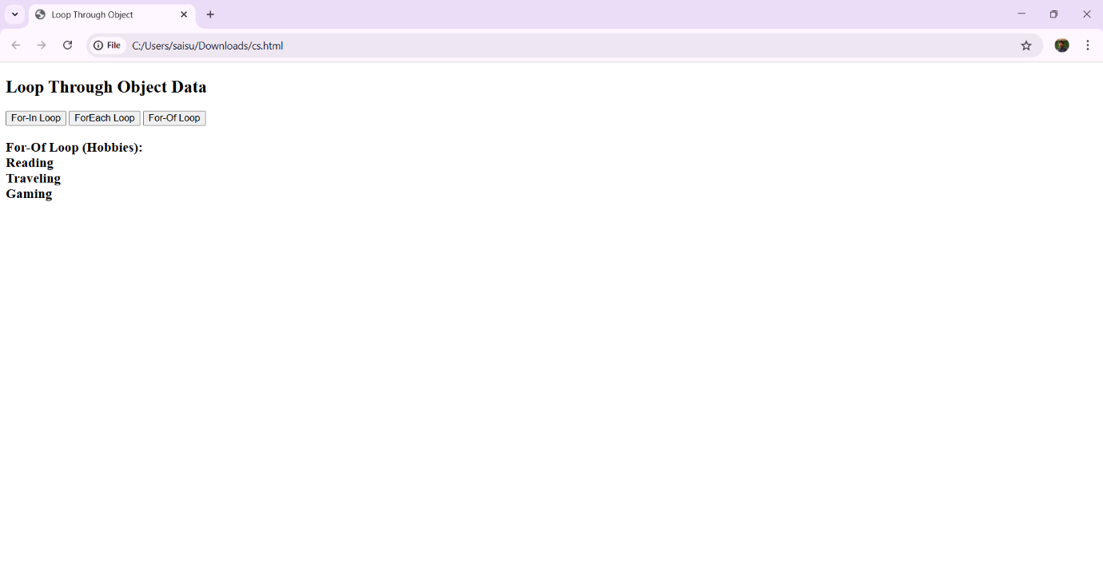

Experiment-8.5: Develop a program to determine whether a given number is an ‘ARMSTRONG NUMBER’ or not. [Eg: 153 is an Armstrong number, since sum of the cube of the digits is equal to the number i.e.,13 + 53+ 33 = 153].

Program:

<!DOCTYPE html>

<html lang="en">

<head>

<title>Armstrong Number Checker</title>

</head>

<body>

<h2>Check if a Number is an Armstrong Number</h2>

<label>Enter a number: </label>

<input type="number" id="numInput">

<button onclick="checkArmstrong()">Check</button>

<h3 id="output"></h3>

<script>

function checkArmstrong() {

let num = document.getElementById("numInput").value;

let sum = 0;

let temp = num;

let digits = num.length; // Number of digits

while (temp > 0) {

let digit = temp % 10; // Get last digit

sum += Math.pow(digit, digits); // Cube (or nth power)

temp = Math.floor(temp / 10); // Remove last digit

}

let message = (sum == num) ? `${num} is an Armstrong Number ✅` : `${num} is NOT an Armstrong Number ❌`;

document.getElementById("output").innerText = message;

}

</script>

</body>

</html>

Output:

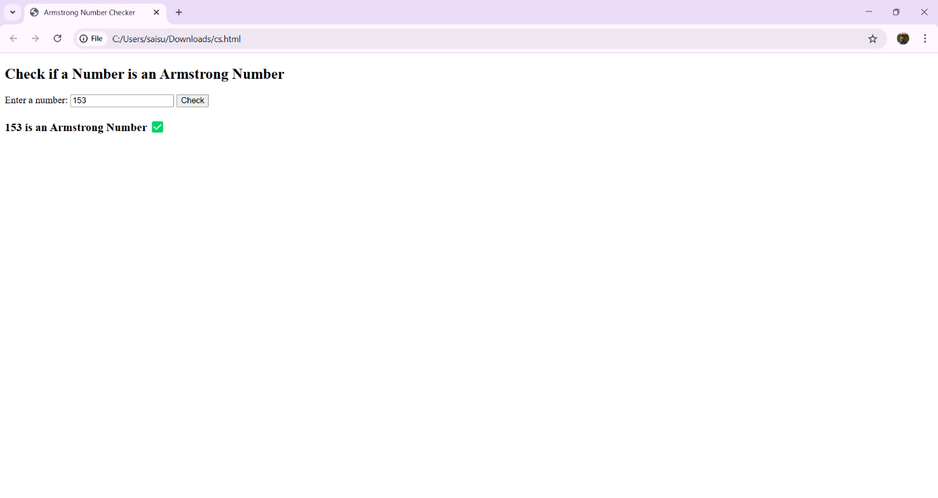

Experiment-8.6: Write a program to display the denomination of the amount deposited in the bank in terms of 100’s, 50’s, 20’s, 10’s, 5’s, 2’s & 1’s. (Eg: If deposited amount is Rs.163, the output should be 1-100’s, 1-50’s, 1- 10’s, 1-2’s & 1-1’s)

Program:

<!DOCTYPE html>

<html lang="en">

<head>

<title>Denomination Calculator</title>

</head>

<body>

<h2>Bank Note Denomination Calculator</h2>

<label>Enter the Amount: </label>

<input type="number" id="amountInput" min="1">

<button onclick="calculateDenominations()">Calculate</button>

<h3 id="output"></h3>

<script>

function calculateDenominations() {

let amount = parseInt(document.getElementById("amountInput").value);

if (isNaN(amount) || amount < 1) {

document.getElementById("output").innerText = "Please enter a valid amount!";

return;

}

let denominations = [100, 50, 20, 10, 5, 2, 1];

let result = `Denomination for Rs.${amount}:\n`;

for (let note of denominations) {

let count = Math.floor(amount / note);

if (count > 0) {

result += `${count} - Rs.${note}'s\n`;

amount %= note; // Reduce the amount

}

}

document.getElementById("output").innerText = result;

}

</script>

</body>

</html>

Output:

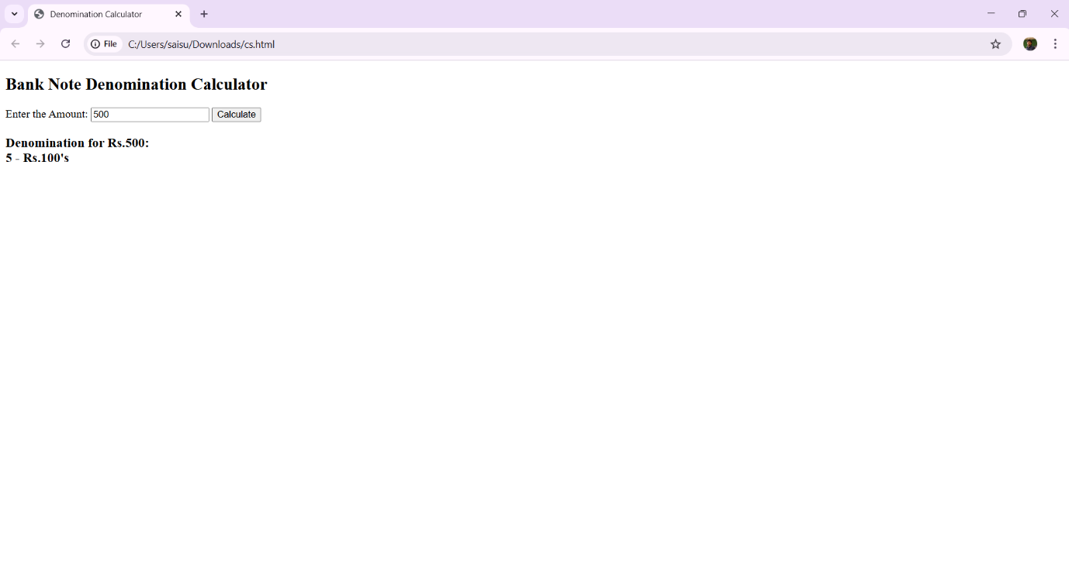

Experiment-9.1: Design a appropriate function should be called to display i. Factorial of that number ii. Fibonacci series up to that number iii. Prime numbers up to that number iv. Is it palindrome or not

Program:

<!DOCTYPE html>

<html lang="en">

<head>

<title>Number Operations</title>

</head>

<body>

<h2>Number Operations</h2>

<label>Enter a Number: </label>

<input type="number" id="numInput" min="1">

<button onclick="calculateFactorial()">Factorial</button>

<button onclick="generateFibonacci()">Fibonacci Series</button>

<button onclick="findPrimes()">Prime Numbers</button>

<button onclick="checkPalindrome()">Palindrome Check</button>

<h3 id="output"></h3>

<script>

// Factorial function

function calculateFactorial() {

let num = parseInt(document.getElementById("numInput").value);

let fact = 1;

for (let i = 1; i <= num; i++) {

fact *= i;

}

document.getElementById("output").innerText = `Factorial of ${num} is: ${fact}`;

}

// Fibonacci Series function

function generateFibonacci() {

let num = parseInt(document.getElementById("numInput").value);

let fibSeries = [0, 1];

for (let i = 2; i < num; i++) {

fibSeries[i] = fibSeries[i - 1] + fibSeries[i - 2];

}

document.getElementById("output").innerText = `Fibonacci Series up to ${num}: ${fibSeries.slice(0, num).join(", ")}`;

}

// Prime Numbers function

function findPrimes() {

let num = parseInt(document.getElementById("numInput").value);

let primes = [];

for (let i = 2; i <= num; i++) {

let isPrime = true;

for (let j = 2; j <= Math.sqrt(i); j++) {

if (i % j === 0) {

isPrime = false;

break;

}

}

if (isPrime) {

primes.push(i);

}

}

document.getElementById("output").innerText = `Prime numbers up to ${num}: ${primes.join(", ")}`;

}

// Palindrome check function

function checkPalindrome() {

let num = document.getElementById("numInput").value;

let reversed = num.split("").reverse().join("");

let message = (num == reversed) ? `${num} is a Palindrome ` : `${num} is NOT a Palindrome `;

document.getElementById("output").innerText = message;

}

</script>

</body>

</html>

Output:

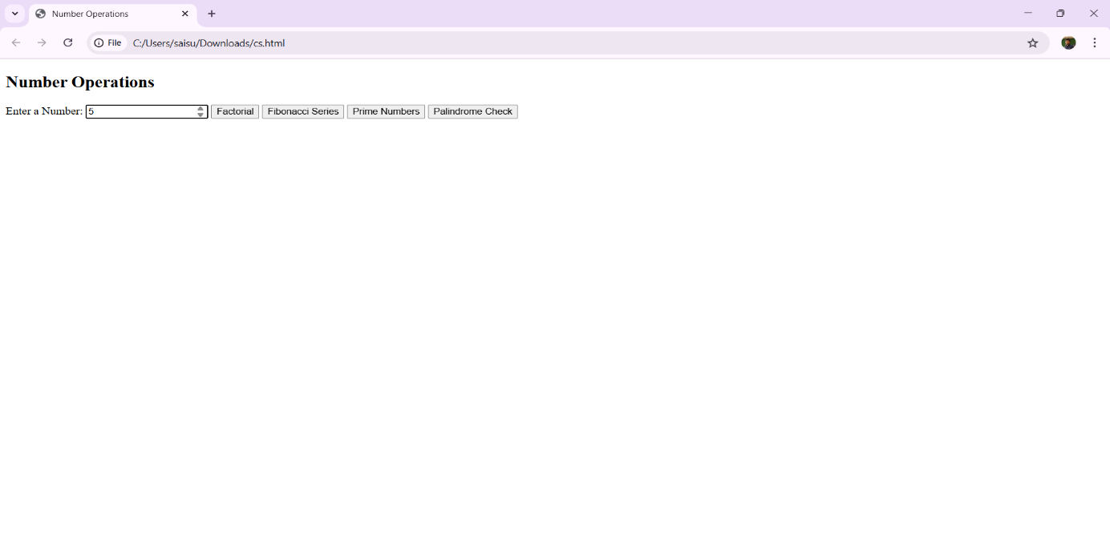

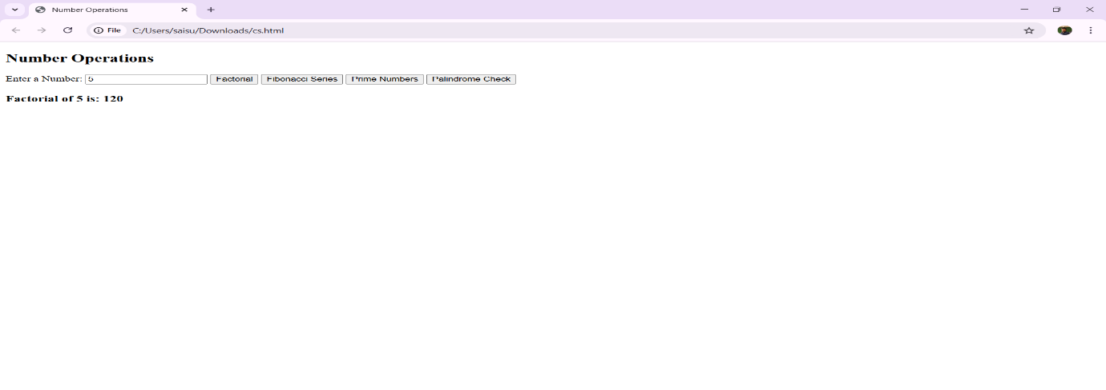

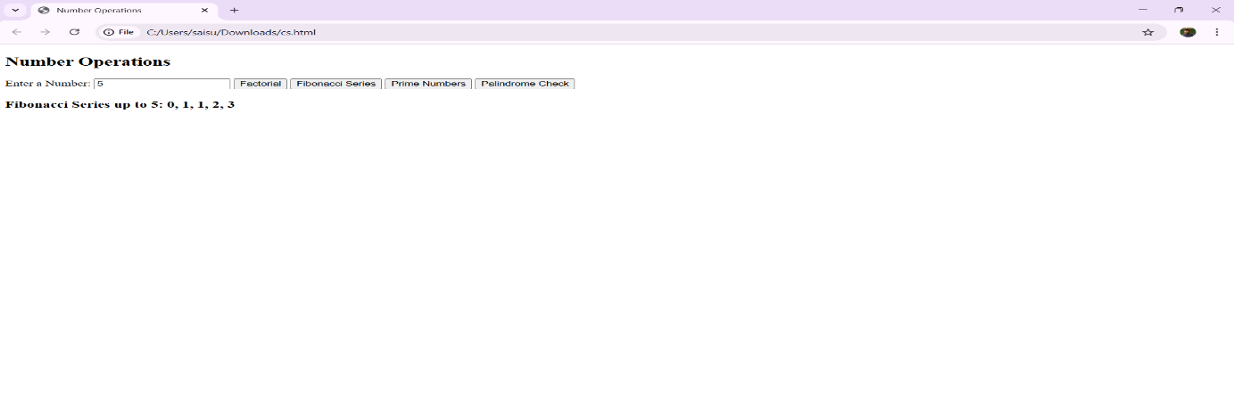

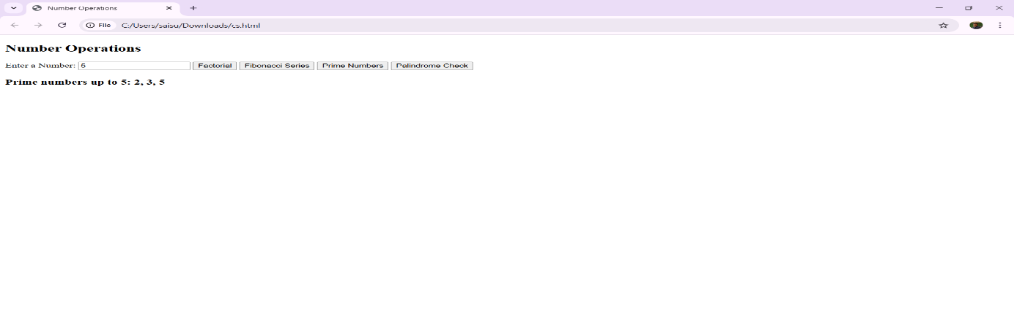

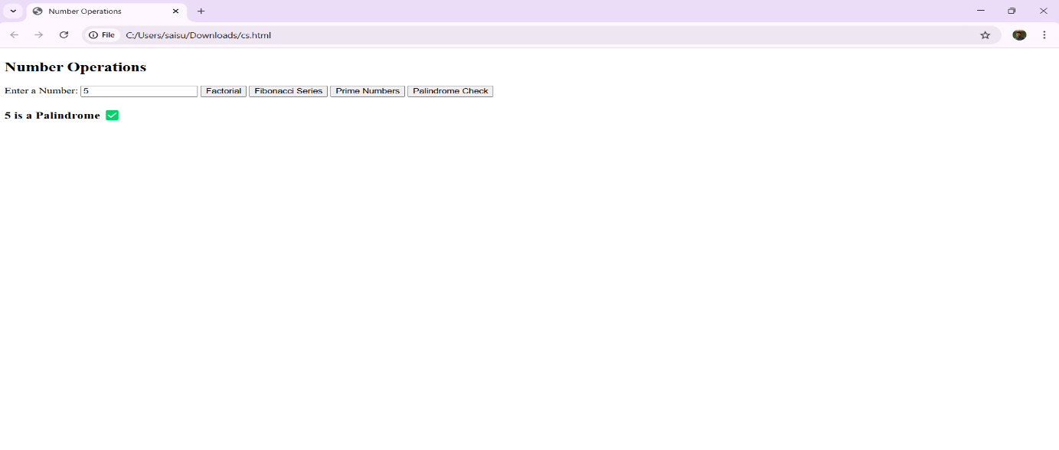

Experiment-9.2: Design a HTML having a text box and four buttons named Factorial, Fibonacci, Prime, and Palindrome. When a button is pressed an appropriate function should be called to display i. Factorial of that number ii. Fibonacci series up to that number iii. Prime numbers up to that number iv. Is it palindrome or not.

Program:

<!DOCTYPE html>

<html lang="en">

<head>

<title>Number Operations</title>

<style>

body {

font-family: Arial, sans-serif;

text-align: center;

margin-top: 50px;

}

input, button {

margin: 5px;

padding: 10px;

font-size: 16px;

}

#output {

margin-top: 20px;

font-size: 18px;

font-weight: bold;

color: blue;

}

</style>

</head>

<body>

<h2>Number Operations</h2>

<label>Enter a Number: </label>

<input type="number" id="numInput" min="1">

<br>

<button onclick="calculateFactorial()">Factorial</button>

<button onclick="generateFibonacci()">Fibonacci</button>

<button onclick="findPrimes()">Prime Numbers</button>

<button onclick="checkPalindrome()">Palindrome</button>

<h3 id="output"></h3>

<script>

// Function to calculate Factorial

function calculateFactorial() {

let num = parseInt(document.getElementById("numInput").value);

if (num < 0 || isNaN(num)) {

document.getElementById("output").innerText = "Please enter a valid positive number!";

return;

}

let fact = 1;

for (let i = 1; i <= num; i++) {

fact *= i;

}

document.getElementById("output").innerText = `Factorial of ${num} is: ${fact}`;

}

// Function to generate Fibonacci Series

function generateFibonacci() {

let num = parseInt(document.getElementById("numInput").value);

if (num < 1 || isNaN(num)) {

document.getElementById("output").innerText = "Please enter a valid positive number!";

return;

}

let fibSeries = [0, 1];

for (let i = 2; i < num; i++) {

fibSeries[i] = fibSeries[i - 1] + fibSeries[i - 2];

}

document.getElementById("output").innerText = `Fibonacci Series up to ${num}: ${fibSeries.slice(0, num).join(", ")}`;

}

// Function to find Prime Numbers up to the given number

function findPrimes() {

let num = parseInt(document.getElementById("numInput").value);

if (num < 2 || isNaN(num)) {

document.getElementById("output").innerText = "Please enter a valid number greater than 1!";

return;

}

let primes = [];

for (let i = 2; i <= num; i++) {

let isPrime = true;

for (let j = 2; j <= Math.sqrt(i); j++) {

if (i % j === 0) {

isPrime = false;

break;

}

}

if (isPrime) {

primes.push(i);

}

}

document.getElementById("output").innerText = `Prime numbers up to ${num}: ${primes.join(", ")}`;

}

// Function to check if the number is a Palindrome

function checkPalindrome() {

let num = document.getElementById("numInput").value;

if (num === "") {

document.getElementById("output").innerText = "Please enter a valid number!";

return;

}

let reversed = num.split("").reverse().join("");

let message = (num === reversed) ? `${num} is a Palindrome ` : `${num} is NOT a Palindrome `;

document.getElementById("output").innerText = message;

}

</script>

</body>

</html>

Output:

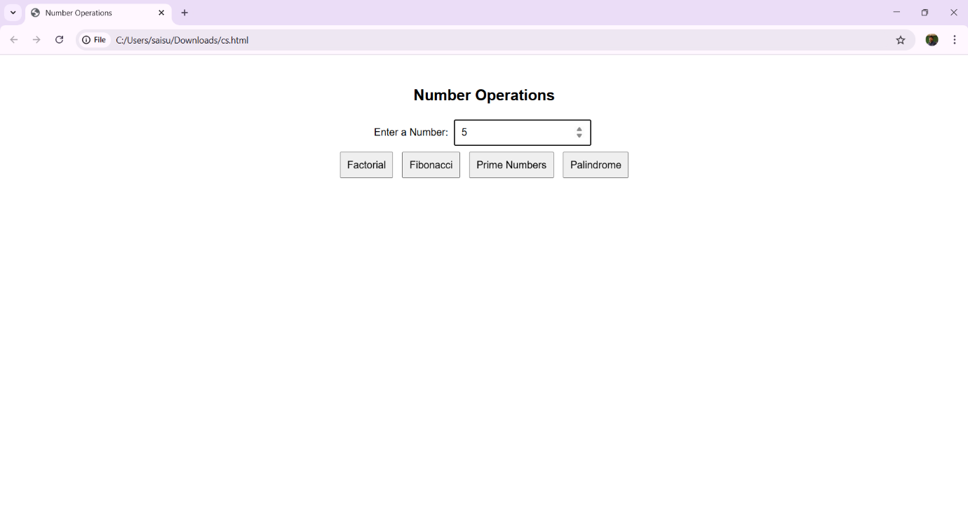

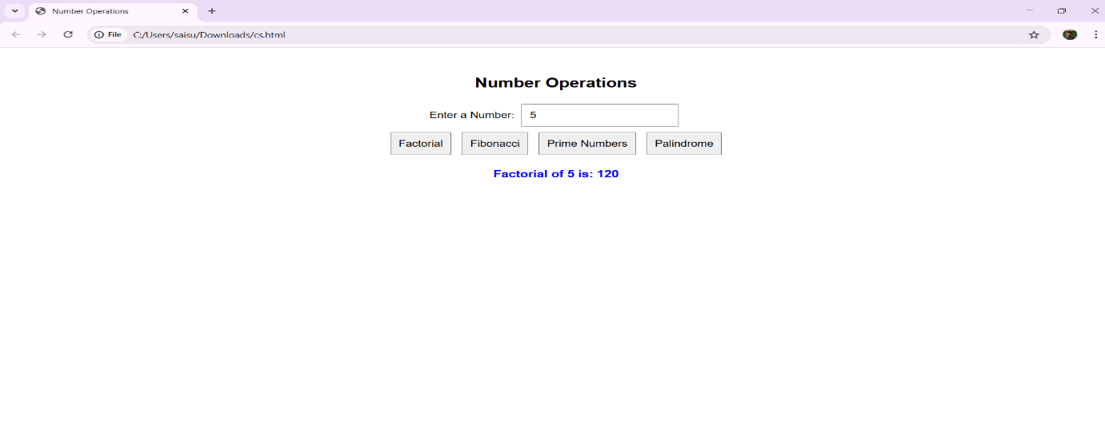

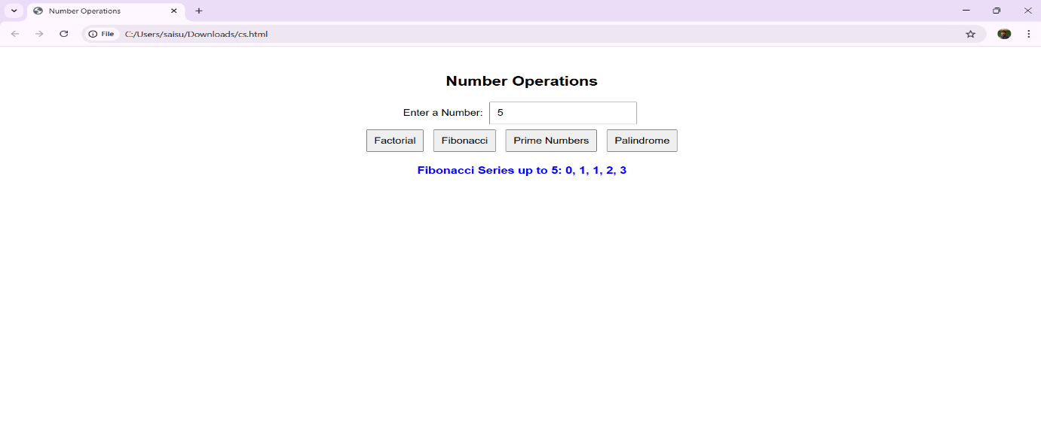

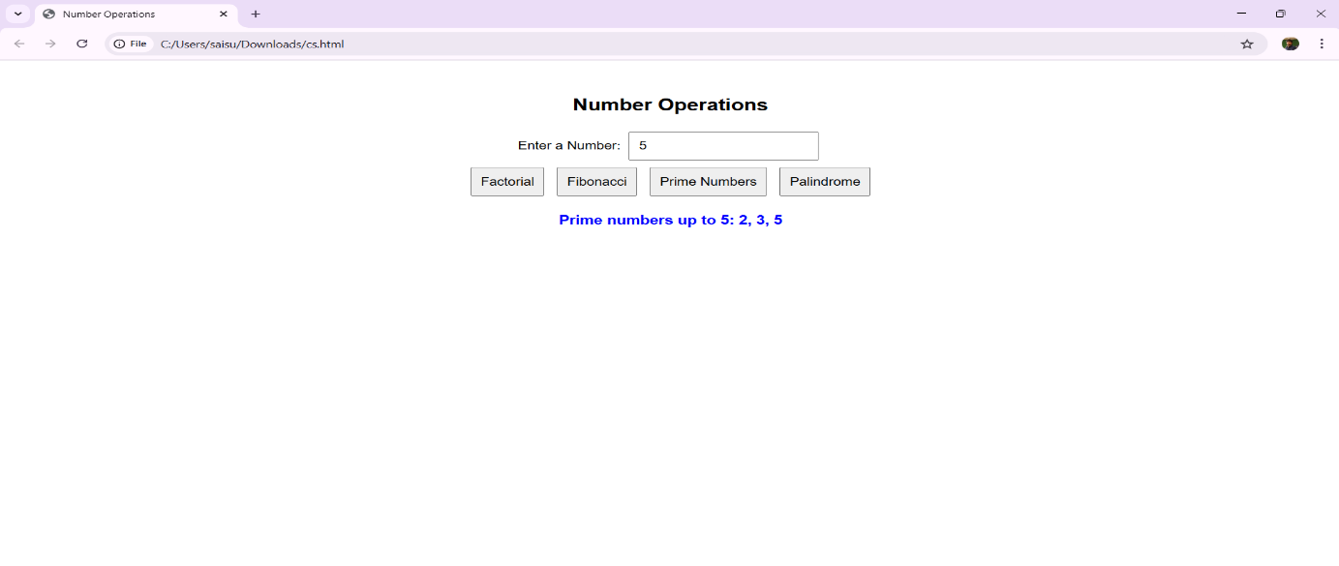

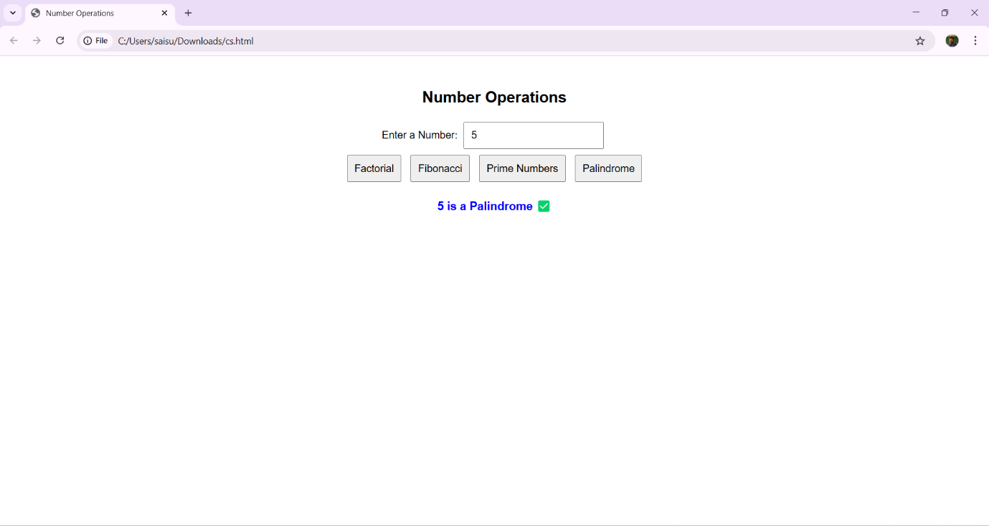

Experiment-9.3: Write a program to validate the following fields in a registration page

i.Name (start with alphabet and followed by alphanumeric and the length should

not be less than 6 characters)

ii. Mobile (only numbers and length 10 digits)

iii. E-mail (should contain format like [xxxxxxx@xxxxxx.xxx](mailto:xxxxxxx@xxxxxx.xxx)).

Program:

<!DOCTYPE html>

<html lang="en">

<head>

<title>Registration Form Validation</title>

<style>

body {

font-family: Arial, sans-serif;

text-align: center;

margin-top: 50px;

}

input, button {

margin: 10px;

padding: 8px;

font-size: 16px;

}

.error {

color: red;

font-size: 14px;

}

</style>

</head>

<body>

<h2>Registration Form</h2>

<form onsubmit="return validateForm()">

<label>Name:</label>

<input type="text" id="name">

<span id="nameError" class="error"></span>

<br>

<label>Mobile:</label>

<input type="text" id="mobile">

<span id="mobileError" class="error"></span>

<br>

<label>Email:</label>

<input type="text" id="email">

<span id="emailError" class="error"></span>

<br>

<button type="submit">Register</button>

</form>

<script>

function validateForm() {

let isValid = true;

// Get input values

let name = document.getElementById("name").value;

let mobile = document.getElementById("mobile").value;

let email = document.getElementById("email").value;

// Regular Expressions for validation

let namePattern = /^[A-Za-z][A-Za-z0-9]{5,}$/; // Starts with a letter, followed by at least 5 alphanumeric chars

let mobilePattern = /^[0-9]{10}$/; // Exactly 10 digits

let emailPattern = /^[a-zA-Z0-9._%+-]+@[a-zA-Z0-9.-]+\.[a-zA-Z]{2,4}$/; // Standard email pattern

// Name Validation

if (!namePattern.test(name)) {

document.getElementById("nameError").innerText = "Invalid name! Must start with a letter and be at least 6 characters long.";

isValid = false;

} else {

document.getElementById("nameError").innerText = "";

}

// Mobile Validation

if (!mobilePattern.test(mobile)) {

document.getElementById("mobileError").innerText = "Invalid mobile number! Must be exactly 10 digits.";

isValid = false;

} else {

document.getElementById("mobileError").innerText = "";

}

// Email Validation

if (!emailPattern.test(email)) {

document.getElementById("emailError").innerText = "Invalid email! Format: example@domain.com";

isValid = false;

} else {

document.getElementById("emailError").innerText = "";

}

return isValid; // Return true if all validations pass, otherwise false

}

</script>

</body>

</html>

Output:

